PHARMACEUTICAL ORGANIC CHEMISTRY –II

LAB MANUAL II/I B.PHARM

LABORATORY SAFETY RULES

- Wear lab coat and approved safety goggles at all times in the laboratory.
- Wear appropriate gloves & it is not advisable to wear contact lenses during lab.
- Wear closed-toe shoes to lab. Legs should be covered as well.
- Do not wear loose clothing to lab.
- Tie back long hair.
- Perform all experimental procedures and operations in the hood.
- Keep the lab neat. Return reagent containers and equipment to proper locations. Replace all caps and lids on reagent containers. Clean all spills in and around balances.
- Place any belongings not needed for experimental work on the shelves provided (or the bench).
- Never put anything in your mouth during lab.

Immediately wash off any chemicals spilled on your skin or clothes.
- Clean up all chemical spills or broken glass immediately.
- Think about how much chemical you will need before you take it from a stock (reagent) bottle. Never return unused chemicals to stock bottles.
- Dispose of waste organic chemicals in the waste bottle provided.

Behave in a responsible manner at all times in lab.
- Be aware of the location of laboratory safety equipment.
- Immediately report accidents and injuries to your instructor.
- Do not perform unauthorized experiments.
- Wash your hands carefully before leaving the laboratory.
- No smoking, eating or drinking in the laboratory.

Treat all laboratory reagents as if they are hazardous.
ISSUES SPECIFIC TO PARTICULAR EXPERIMENTS

  - Never pipette by mouth.
  - Carefully inspect glassware for damage.
  - Use caution when heating reactions.
  - Handle hot objects with caution.
  - Use a fume hood or snorkel when working with harmful vapors.
  - Do not use open flames in the presence of flammable materials.
  - Prepare acid solutions carefully
  - Do not force a thermometer or glass tubing into a stopper.
  - Do not taste anything in the laboratory.
  - Do not point the mouth of a reaction vessel containing chemicals toward yourself or toward anyone else.
  - Never leave any reaction unattended.
  - Please be careful to avoid contaminating reagents for others and for your later use.

RECRYSTALLIZATION

Recrystallization (or Crystallization) is a technique used to purify solids. This procedure relies on the fact that solubility increases as temperature increases (you can dissolve more sugar in hot water than in cold water). As a hot, saturated solution cools, it becomes supersaturated and the solute precipitates (crystallizes) out. In a recrystallization procedure, an impure (crude) solid is dissolved in a hot solvent. As this solution is cooled, the pure product crystallizes out and the impurities stay dissolved.

The slower the rate of cooling, the larger the crystals are that form. The disadvantage of recrystallization is that it takes a long time. Also, it is very important that the proper solvent is used. This can only be determined by trial and error, based on predictions and observations. The solution must be soluble at high tempratures and insoluble at low temperatures. The advantage of recrystallization is that, when carried out correctly, it is a very effective way of obtaining a pure sample of some product, or precipitate.

Procedure

These are the important steps to the recrsytallization process.
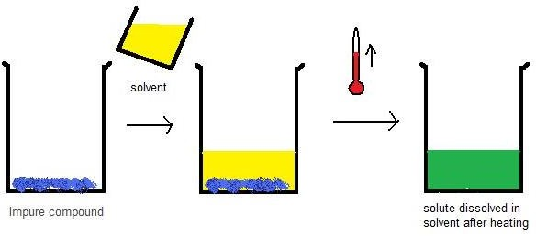

- Dissolve the solute in the solvent: Add boiling solvent to a beaker containing the impure compound. Heat the beaker and keep adding solvent until the solute is completely dissolved.
- Cool the Solution: The solution is cooled in open air first, and then cooled in an ice bath. Slow cooling often leads to purer crystals. Crystals should form on the bottom of the beaker. The process of "seeding" can be used to aid the formation of crystals- this means adding a pure crystal of the compound. The pure crystal forms a surface for the solute to crystallize upon.
- Obtain the crystals of the solute: The more pure crystals of the solute are the desirable part of the mixture, and so they must be removed from the solvent. The process used for isolating the crystals that remain in the beaker still is called vacuum filtration. Suction is created using an aspirator, and whatever remains in the beaker is poured though a Buchner funnel. If for some reason there are no crystals visible, a gravity filtration can be performed. Activated carbon is added to the solution, the mixture is boiled, and a funnel system is used to transfer the new mixture to a new beaker of boiling solvent. Filter paper is used in the funnel to remove excess carbon. After this mixture cools slowly there should be large crystals present.
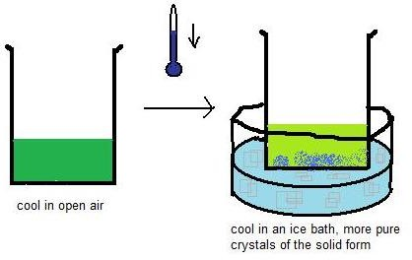

- Dry the resulting crystals: The crystals are dried by leaving them in the aspirator and then by removing them to a glass dish to wait a while longer. The purity of the crystals can be tested by performing a "melting point determination".

STEAM DISTILLATION

Steam distillation is a separation process used to purify or isolate temperature sensitive materials, like natural aromatic compounds. Steam or water is added to the distillation apparatus, lowering the boiling points of the compounds. The goal is to heat and separate the components at temperatures below their decomposition point.

The advantage of steam distillation over simple distillation is that the lower boiling point reduces decomposition of temperature-sensitive compounds. Steam distillation is useful for the purification of organic compounds, although vacuum distillation is more common. When organics are distilled, the vapor is condensed. Because water and organics tend to be immiscible, the resulting liquid generally consists of two phases: water and the organic distillate. Decantation or partitioning may be used to separate the two layers to obtain the purified organic material.

Principle behind Steam Distillation

When a mixture of two immiscible liquids (e.g., water and organics) is heated and agitated, the surface of each liquid exerts its own vapor pressure as though the other component of the mixture was absent. Thus, the vapor pressure of the system increases as function of temperature beyond what it would be if only one of the components was present. When the sum of the vapor pressures exceeds atmospheric pressure, boiling begins. Because the temperature of boiling is reduced, damage to heat-sensitive components is minimized.

Uses of Steam Distillation

Steam distillation is the preferred method used to isolate essential oils. It is also used for "steam stripping" in petroleum refineries and to separate commercially important organic compounds, such as fatty acids.
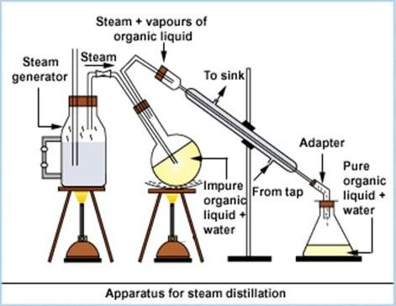

Procedure
- The organic mixture together with some water is placed in an R.B flask which is then connected to a steam generator on one side & a water condenser on the other.
- Heat the mixture to avoid the condensation of steam in it.
- The water in the flask is heated & then a current of steam is passed in to the mixture.
- The required compound to be separated is steam volatile so it readily passes over in the steam.
- The vapours of the compound along with steam leaves the flask from the outlet & gets condensed in the water condenser.
- It is then collected in a conical flask containing ice to solidify the liquid.
- Pure compound is filtered at the Buchner funnel and the residue in the distillation .

PREPARATION OF ACETANILIDE

Aim: To prepare acetanilide from aniline by acylation reaction and find out percentage yield. Apparatus: Beakers, glass rod, conical flask, burner, weighing balance, condensor Chemicals: Acetic anhydride, glacial acetic acid, aniline.

Principle:
Acetanilide is prepared from aniline by acetylating it with acetic anhydride in presence of glacial acetic acid. Aniline is a primary amine and basic in nature. Acetic anhydride acts here as a source of acyl groups. Aniline reacts with acetic anhydride to form acetanilide by nucleophilic substitution reaction and the reaction is called as acetylation. In this reaction, aniline act as a nucleophile and acyl group from acetic anhydride act as an electrophile and the –H atom of NH2 in aniline is replaced by acyl group.

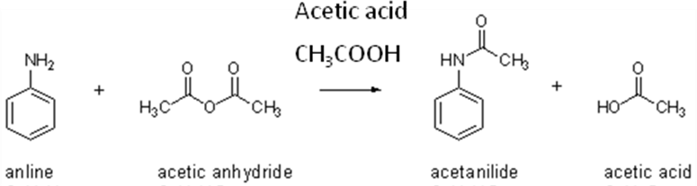

Procedure:
Add 20 ml of a mixture of acetic anhydride and glacial acetic acid (in equal volumes) to 10 ml of aniline in a round bottomed flask. Fit a reflux condenser to the flask and gently boil the mixture for 60 minutes. Then pour the hot liquid into 200 ml cold water with constant stirring. The acetanilide quickly crystallizes. Filter the product and wash well with water and dry. Recrystallise the crude acetanilide from 60 ml of mixture of one volume acetic acid and two volumes water. Filter the crystals, wash well with water and dry. Determine the melting point of the product.
The melting point of Acetanilide is 114ºC.

Uses: It is used in the manufacture of colored dyes for fabrics and textiles, as a reagent in the production of rubber, as a hydrogen peroxide decomposition inhibitor and also a building block in the synthesis of penicillin.

Report: Acetanilide was prepared & submitted. The percentage yield was found to be as

PREPARATION OF PARA-BROMO ACETANILIDE

Aim: To prepare para bromo acetanilide from acetanilide by halogenations reaction and find out percentage yield.

Apparatus: beakers, glass rod, conical flask, burner, weighing balance

Chemicals: Acetanilide, glacial acetic acid, bromine, rectified spirit.

Principle: p-bromo acetanilide is prepared from acetanilide by bromination process. Bromination of acetanilide occurs at the para position due to the amine substituent. This substituent provides resonance stabilization to the carbocations created by ortho and para addition. Since the amine provides steric hindrance at the ortho position, bromination of acetanilide occurs at the para position.

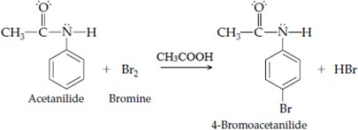

Procedure:
In a conical flask, dissolve 10gm of acetanilide in 45 ml of glacial acetic acid and cool to below 5ºC. Add 4.2 ml of bromine to 25 ml of cold acetic acid drop wise with constant stirring. Now add this bromine solution to the acetanilide mixture drop wise with constant stirring, flask should be kept in cold water. When the addition of bromine is completed, the solution turns orange due to some excess of bromine, then allow the mixture to stay in room temperature for 30 minutes. Pour the contents of the flask in a beaker containing 200 ml of ice cold water. Rinse the conical flask with ice cold water and pour to the beaker with constant stirring. Para bromo acetanilide gets separates as white solid. Filter the crude product and wash the residue with cold water. Recrystallise the product from rectified spirit and dry. Determine the melting point of the product.
The melting point of p- bromo Acetanilide is 165-169ºC

Uses: p- bromo acetanilide is used as a substrate in many chemical synthesis.

Report: p- bromo Acetanilide was prepared & submitted. The percentage yield was found to be as

PREPARATION OF m-DINITROBENZENE
Aim: To prepare m- dinitro benzene from nitro benzene by nitration reaction and find out percentage yield.

Apparatus: Beakers, glass rod, conical flask, burner, weighing balance

Chemicals: concentrated sulfuric acid nitrobenzene conc. Nitric acid

Principle: The preparation of m-dinitro benzene from nitrobenzene undergoes nitration reaction. It is an electrophilic aromatic substitution in presence of NO2, which is a strong electron withdrawing group and directs the upcoming substituents at meta position. Here nitronium ion act as an electrophile which is generated from fuming nitric acid in presence of sulphuric acid.

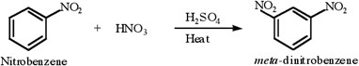

Procedure
In a RBF add concentrated sulfuric acid 21ml and to this add nitrobenzene 12.5 ml and stir well, add 21ml of conc. Nitric acid slowly over a period of about three minutes. Heat the reaction mixture in a boiling water bath for about 25 minutes. Cool the mixture in an ice bath. While stirring, slowly add ice chips to the reaction. A solid should form. Cool the product mixture in an ice bath. Collect the crude solid product. Use a few drops of ice cold water to rinse the product. Recrystallise the product from rectified spirit and dried. Determine the melting point of the product.
The melting point of m- dinitro benzene is 90 ºC.

Uses: It is used in Organic drug synthesis.

Calculation:

Report: m- dinitro benzene was prepared & submitted. The percentage yield was found to be as

PREPARATION OF BENZOIC ACID FROM BENZYL CHLORIDE
Aim: To prepare benzoic acid from benzyl chloride by oxidation reaction and find out percentage yield.

Apparatus: beakers, glass rod, conical flask, burner, weighing balance, condensor

Chemicals: Benzyl chloride, anhydrous sodium carbonate, potassium permanganate, sodium sulfite, concentrated hydrochloric acid

Principle: In this reaction a side chain oxidation is performed. In order to achieve this benzyl chloride is mixed with sodium carbonate solution and is oxidized with potassium permanganate solution. The sodium salt of benzoic acid is formed; this is acidified with concentrated hydrochloric acid when benzoic acid crystallizes out

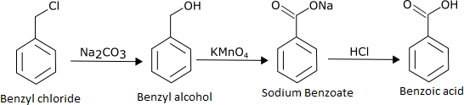

Procedure:
About 2 ml of benzyl chloride is added to a solution of about 2 g of anhydrous sodium carbonate dissolved in 20 ml of distilled water. The mixture is taken in a round bottom flask. The round bottom flask is fitted with a water reflux condenser and heated. 4 g of potassium permanganate in 80 ml of water is added in small quantities through the water condenser until a permanent pink color persists even after continuous boiling. It is boiled for about 1 hour. The mixture is not transferred to a beaker. About 4 grams of sodium sulfite are added to this mixture. Now add concentrated hydrochloric acid to this solution until the solution is acidic. The solution is cooled; precipitated benzoic acid is filtered and washed. The product is recrystallized from boiling water. The melting point benzoic acid is 121ºC.

Uses : Benzoic acid and its salts are used as a food preservatives, also it is a constituent of Whitfield's ointment which is used for the treatment of fungal skin diseases such as tinea, ringworm, and athlete's foot.

Calculation:

Report: Benzoic acid was prepared & submitted. The percentage yield was found to be as

PREPARATION OF BENZOIC ACID FROM ETHYL BENZOATE

Aim: To prepare benzoic acid from ethyl benzoate by hydrolysis reaction and find out percentage yield.

Apparatus: beakers, glass rod, conical flask, burner, weighing balance, condensor Chemicals: ethyl benzoate, sodium hydroxide, concentrated hydrochloric acid Principle:
Benzoic acid can be prepared by the alkaline hydrolysis of the ester ethyl benzoate
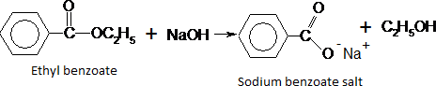

The sodium benzoate salt is soluble in the reaction mixture so hydrochloric acid is used to displace the insoluble benzoic acid
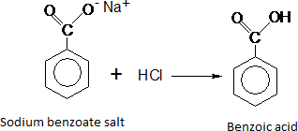

This process is called base hydrolysis where Ethyl benzoate is heated with aqueous sodium hydroxide. At the start of the reaction the flask contains two immiscible layers, a liquid layer of the water insoluble ethyl benzoate floating on the aqueous sodium hydroxide layer. As the ethyl benzoate reacts, water soluble products are formed and the upper layer decreases in size until a homogeneous solution is obtained and the reaction is complete.

Procedure:
In a round-bottomed flask add 5.0 mL of ethyl benzoate, 30 ml of sodium hydroxide followed by 3 or 4 porceline pieces to the ethyl benzoate in the flask and attach it to the condenser. Heat the flask gently and the mixture in the flask should be shaken almost continuously to speed up the hydrolysis reaction. When all of the oily drops of ester have disappeared (about 15 minutes) and the solution is almost clear, stop heating and cool the reaction mixture to room temperature by holding an ice bath up around the flask. Add 10 mL of concentrated hydrochloric acid and added cautiously to the contents of beaker while stirring the solution with a glass rod. Allow the mixture to cool to room temperature and collect the precipitated solid using a buchner flask and funnel. Recrystallized the sample from boiling water.
The melting point of benzoic acid is 121 ºC
Uses : Benzoic acid and its salts are used as a food preservatives, also it is a constituent of Whitfield's ointment which is used for the treatment of fungal skin diseases such as tinea, ringworm, and athlete's foot.

Calculation:

Report: Benzoic acid was prepared & submitted. The percentage yield was found to be as

PREPARATION OF PHENYL–AZO–β-NAPHTHOL (AN AZO DYE)

Aim: To prepare phenyl–azo–β-naphthol (an azo dye) from aniline by diazotization and find out percentage yield.

Apparatus: beakers, glass rod, conical flask, burner, weighing balance

Chemicals: Concentrated hydrochloric acid, aniline, sodium nitrite, β-naphthol, 10% sodium hydroxide solution.

Principle:
Aniline is an aromatic primary amine. It forms diazonium salt when treated with nitrous acid at 0-5°C. The process is called diazotisation. Nitrous acid is generated in situ by the reaction of sodium nitrite with hydrochloric acid. The diazonium salt is coupled with an alkaline solution of β-naphthol to form an orange-red azo dye.

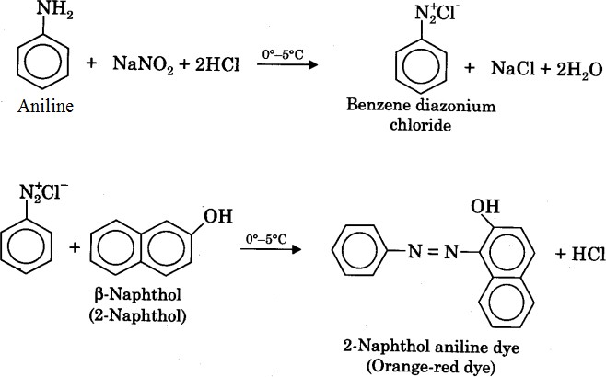

Procedure
Take 6.5 mL of concentrated hydrochloric acid in a 100 mL beaker. Dilute it with 6.5 mL of water and dissolve 2 mL of aniline in it. Cool the above mixture by placing the beaker in an ice bath maintained at 0-5°C temperature. Diazotise the above mixture by adding a solution of 1.6 g of sodium nitrite in 8 mL water. Dissolve 3.2 g β-naphthol in 18 mL of 10% sodium hydroxide solution. Add about 25 g of crushed ice to it. Stir the β-naphthol solution well and add chilled diazonium chloride solution very slowly to it with constant stirring. An orange red dye of phenyl-azo-β-naphthol is formed. Allow the mixture to stand in the bath for 30 minutes with occasional shaking. Filter the crystals obtained and wash them well with cold water. Recrystallise about one-fourth of the crude product from glacial acetic acid. Record the yield and the melting point of the compound.
The melting point of phenyl–azo–β-naphthol is 131ºC.

Uses : It is used as a coloring dye.

Calculation:

Report: Phenyl-azo- β-naphthol was prepared & submitted. The percentage yield was found to be as

PREPARATION OF DIBENZALACETONE

Aim : To prepare Dibenzal acetone from benzaldehyde by Claisen-Schmidt reaction and find out percentage yield.

Apparatus: Beakers, glass rod, conical flask, burner, weighing balance, condensor

Chemicals: Benzaldehyde, ethanol, 3M sodium hydroxide, acetone.

Principle:
The reaction of an aldehyde with a ketone employing sodium hydroxide as the base is an example of a mixed aldol condensation reaction, the Claisen-Schmidt reaction. Dibenzalacetone is readily prepared by condensation of acetone with two equivalents of benzaldehyde. The aldehyde carbonyl is more reactive than that of the ketone and therefore reacts rapidly with the anion of the ketone to give a β-hydroxyketone, which easily undergoes basecatalyzed dehydration. Depending on the relative quantities of the reactants, the reaction can give either mono- or dibenzalacetone.
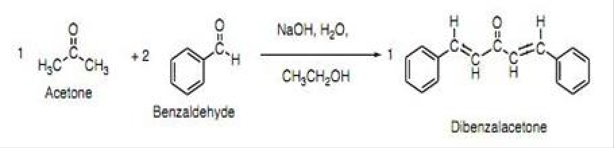

Procedure

In a RBF, place cold solution of 25 mg NaOH in 250 ml of water and 200 ml of ethanol. Place the flask with a stirrer surround it with a waterbath. Maintain the temperature of solution 20-25ºC, stir vigorously and add half of the prepared mixture of 26.5gm benzaldehyde and 7.3gm of acetone. A flocculent precipitate forms in 2-3 minutes. After 15 minutes, add the remaining benzaldehyde-acetone mixture. Continue stirring for a further 30 minutes. Filter and wash with cold water to eliminate alkali. Dry at room temperature and recrystallise with hot ethyl acetate.
The melting point of Dibenzal acetone is l10.5-112°C.

Uses : It is used as a component in sunscreens.

Calculation:

Report: Dibenzalacetone was prepared & submitted. The percentage yield was found to be as

SYNTHESIS OF BENZIL

Aim : To prepare Benzil from benzoin by oxidation reaction and find out percentage yield.

Apparatus: Beakers, glass rod, conical flask, burner, weighing balance

Chemicals: Benzoin, Conc.HNO3.

Principle: The objective of this experiment is to oxidize benzoin into benzil in an acidic environment. This oxidation can easily be done with a variety of mild oxidizing agents, including Fehling's solution (an alkaline cupric tartrate complex) or copper (II) sulfate in pyridine. In addition, benzoin could be oxidized by sodium dichromate, but the yield of benzil is lower.

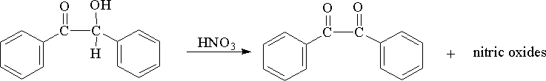

Procedure
Place 20gm of crude benzoin and 100ml of conc. HNO3 in 250ml RBF. Heat on boiling water bath with occasional shaking until the evolution of oxides of nitrogen has ceased (90 minutes). Pour the reaction mixture in 300-400ml cold water in a beaker, stir well until oil crystallizes completely as yellow solid. Filter benzil, wash with water to remove nitric acid. Recrystallise from ethanol, melting point is found to be 94-96ºC

Uses: Benzil is used as a standard building block in organic synthesis.

Calculation:

Report: Benzil was prepared & submitted. The percentage yield was found to be as

SYNTHESIS OF CINNAMIC ACID FROM BENZALDEHYDE

Aim: To synthesize trans-cinnamic acid from benzaldehyde and acetic anhydride by Perkin condensation reaction and find out percentage yield.
Apparatus: Beakers, glass rod, conical flask, burner, weighing balance

Chemicals: Benzaldehyde, potassium acetate, acetic anhydride, Na2CO3, 6 M HCl

Principle: The formation of cinnamic acid from benzaldehyde undergoes perkin condensation. Perkin condensation is the condensation of an aromatic aldehyde with an acid anhydride in presence of sodium or potassium salt of the acid corresponding to the anhydride to yield an α,β-unsaturated acids. In this preparation benzaldehyde is reacted with acetic anhydride in presence of potassium acetate salt to yield cinnamic acid.
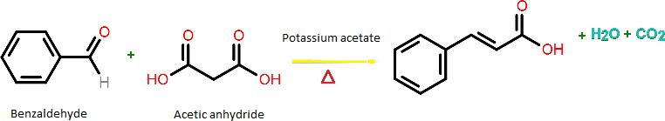

Procedure
To a RBF add benzaldehyde 1 mL, potassium acetate 600 mg, and acetic anhydride 1.4 mL. A condenser was attached and the system was heated to reflux in a sand bath at 180° C for 1 hour. The reaction mixture was cooled, quenched with water (40 mL), made basic (pH 8-10) with saturated Na2CO3, transfer this aqueous solution to a separatory funnel and extract three times with 10 mL of tert-butyl methyl ether (BME). The organic extracts will be discarded at the end of the experiment. Crude product was precipitated from the aqueous layer with 6 M HCl (p^{H} 2), cooled in an ice bath, and then isolated as a white solid filtration. Recrystallize the sample. Determine the melting point of the product the melting point of pure cinnamic acid – 133° C.
Uses: Cinnamic acid is used in flavors, synthetic indigo, and certain pharmaceuticals. A major use is in the manufacturing of the methyl, ethyl, and benzyl esters for the perfume industry.

Calculation:

Report: Cinnamic acid was prepared & submitted. The percentage yield was found to be as

SYNTHESIS OF p-IODOBENZOIC AICD FROM p-AMINOBENZOIC AICD.

Aim: To prepare p-Iodobenzoic acid from p-Amiobenzoic acid and find out percentage yield.

Apparatus:

Chemicals: p –Amino benzoic acid, concentrated HCl, sodium nitrate and potassium iodide.

Principle: p –Amino benzoic acid in the presence of nitrous acid which is generated in-situ by the reaction between sodium nitrate and concentrated HCl forms diazonium salt. This rapidly undergoes replacement of diazonium group by iodine when reacted with potassium iodide to give p- Iodo benzoic acid.

Procedure:

DETERMINATION OF IODINE VALUE
AIM: To determine the iodine value of given substance.
APPARATUS: Dry Iodine flask, burette, etc.
CHEMICALS REQUIRED:-Carbon tetra chloride, Pyridine bromide, potassium iodide, sodium thiosulphate, starch solution as indicator.

PRINCIPLE:

The Iodine value is defined as the amount of iodine absorbed by 100 parts by weight of the substance. This is determined by two methods.
- Iodine monochloride method
- Pyridine bromide method

Iodine monochloride method

Fatty acids react with a halogen [Iodine] resulting in the addition of the halogen at the C=C double bond site. In this procedure, instead of Iodine, Iodine Monochloride is used because of its reactivity. I Cl react with the unsaturated bonds to produce a di-halogenated compound.

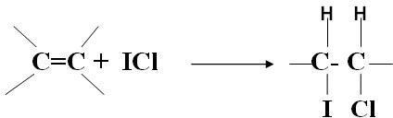

In the procedure, the known excess of I Cl reagent is added and then the excess I Cl is treated with potassium iodide for the liberation of iodine.

ICl + KI ---------------> KCl + I2
The liberated I2 is then titrated with a standard solution of 0.1N sodium thiosulfate using starch solution as indicator.

I2 + 2 Na2S2O3 -----------------> 2 NaI + Na2S2O4

Method-II
Pyridine bromide method Procedure:
Place an accurately weighed quantity of the substance in a dry iodine flask, Add 10 ml of carbon tetrachloride and dissolve. Add 25 ml of pyridine bromide solution; allow standing for 10 minutes in the dark place. Add 15 ml of potassium iodide solution in the cup top, carefully remove the stopper, rinse the stopper and the sides of the flask with 100 ml of water, shake and titrate with 0.1 M sodium thiosulphate using starch solution, added towards the end of titration, as indicator. Note the number of ml required (a). Repeat the procedure without the substance and note number of ml required (b). Calculate the iodine value using the equation.

Iodine value= 1.269 (b-a) / w

Where, w= weight, in g, of the substance.

Note: the approximate weight in g, of the substance to be taken may be calculated by dividing with 12.5 by the highest expected iodine value. If more than half the available halogen is absorbed, the test must be repeated with smaller quantity of the substance.
Saturated fatty acids (fats) will not give the halogenation reaction. Fixed oils are mainly containing unsaturated triglycerides therefore they absorb iodine. If the iodine number is between 0-70, it will be a fat and if the value exceeds 70, it is oil.

Significance:
- Iodine number is often used to determine the amount of unsaturation in fatty acids. The higher the iodine number, the more C=C bonds are present in the fat.
- It is an important parameter in quality control of oils.

NOTE:

Every oil has a specific acid value as per monograph which is an indication of its freshness.

Eg: Arachis oil: Iodine value: 85-105.

REPORT:
DETERMINATION OF ACID VALUE

AIM: To determine the acid value of the given substance.
APPARATUS: Dry flask, reflux condenser, water bath, burette etc.
CHEMICALS REQUIRED: Potassium hydroxide, phenolphthalein, ether and ethanol.

PRINCIPLE:
Oils/ fats are evaluated by certain quantitative chemical tests like acid value, saponification value, iodine value, ester value, acetyl value etc.
Acid value is defined as the no. of milligram of KOH required to neutralize free fatty acids in 1 gm of an oil or fat.
If the samples of oil are not properly preserved, they undergo ‘Rancidity’ Rancidity is the hydrolytic or oxidative cleavage of triglycerides causing the formation of free fatty acids in oils or fats. The formation of free fatty acids leads to the development of foul odour as well as disagreeable taste.
In the estimation, the given oil sample is made soluble in the mixture of ether and ethanol and titrated against standard alkali using phenolphthalein as indicator
R-COOH+ K OH R -COOK + HOH
Fatty acid Soap

Significance:
Acid value is the measure of freshness of oils. Oils generally tend to undergo rancidity or degradation due to hydrolysis of triglycerides leading to the formation of free fatty acids in the sample. As the rancidity increases, the amount of free fatty acids will increase. Therefore, the acid value is very high.

PROCEDURE:

- Weigh accurately about 10 gms of substance and add 50 ml of mixture of equal volume of ethanol and ether and dissolve.
- Heat this mixture for 10 minutes by using the heater.
- Add 1 ml of phenolphthalein solution and titrate with 0.1 M KOH until the solution remains faintly pink.

Standardization Procedure of KOH solution:

  - Take 20 ml of 0.1 N oxalic acid solution in a 250 ml conical flask.
  - Add 1 or 2 drops of phenolphthalein indicator to this solution.
  - Titrate this solution against KOH taken in a burette.
  - The appearance of pink color indicates the end point.
  - From the volume of the KOH solution in burette, find the normality of KOH.

Calculation:
Volume of oxalic acid (V1) = 20 ml Normality of oxalic acid (N1) =0.1 N Volume of KOH consumed (V2) =
Normality of KOH consumed (N2) = V1 N1 / V2 Normality of KOH (N2) = .

Acid value =
Volume of KOH x Normality of KOH x 0.0561 x 1000)

Weight of Oil sampleX0.1

REPORT: the acid value of the given sample was found to be

NOTE:

Every oil has a specific acid value as per monograph which is an indication of its freshness. Eg: Arachis oil: Acid value: NMT 0.5

DETERMINATION OF SAPONIFICATION VALUE
AIM: To determine the saponification value of given substance.
APPARATUS: Flask, reflux condenser, burette, etc.
CHEMICALS REQUIRED:-Alcoholic KOH, sodium carbonate, distilled water.
PRINCIPLE: Saponification value/number can be defined as mg of KOH required to saponify 1gm of fat/oil. It is determined by boiling the weighed amount of substance with standard alcoholic solution under reflux for 30 min. the excess unreacted alcoholic KOH solution is back titrated with 0.5M HCl using phenolphthalein as indicator. The end point is pink colour changes to colourless.
PROCEDURE: In a clear RBF take 2gms of sample along with 25ml of 0.5M ethanolic KOH. Stirr it well and connect reflux condenser and reflux it for 30min on water bath. Cool to room temperature and add few drops of phenolphthalein indicator and titrate it against 0.5M HCl until the colour changes from pale pink to colourless. Repeat the blank titration and note down the burette reading.
Standardization Procedure of 0.5M HCl: Weigh accurately 1.5gm of Na2CO3 in a conical flask add 100ml of water add methyl red indicator and titrate against 0.5 HCl. The end point is determined as colour changes from yellow to red.
Report: The saponification value of the given sample was found to be

