 | Dr. SAMUEL GEORGE INSTITUTE OF PHARMACEUTICAL SCIENCES  Markapur, Prakasam (Dt). 523316, Andhra Pradesh  (Sponsored by TSG Society , Affiliated to Acharya Nagarjuna University, Approved by AICTE & PCI) Website: www.drsgips.ac.in/ Email: drsgips04@gmail.com Ph: 7093281133

LABORATORY MANUAL FOR

B. PHARMACY II YEAR

MEDICINAL CHEMISTRY – I

List of Experiments
I Preparation of drugs/ intermediates
  - 1,3-pyrazole
  - 1,3-oxazole
  - Benzimidazole
  - Benzotriazole
  - 2,3- diphenyl quinoxaline
  - Benzocaine
  - Phenytoin
  - Phenothiazine
  - Barbiturate

Assay of drugs
  - Chlorpromazine
  - Phenobarbitone
  - Atropine
  - Ibuprofen
  - Aspirin
  - Furosemide

Determination of Partition coefficient for any two drugs

INTRODUCTION TO CHEMICAL HANDLING AND SAFETY IN THE LABORATORY:

INSTRUCTIONS TO THE CANDIDATE:
- Before entering in the Laboratory:
¬ One should wear a clean, white Apron.
¬ Ensure that you are with all the necessary writing material, observation book, calculator, pencil, eraser, requirements box and a neatly covered journal completed in all aspects.
- While working in the laboratory:
¬ Maintain discipline and cleanliness. Never lean on the platforms. Follow the instructions given by teacher scrupulously.
¬ Follow the SOPs correctly while operating the equipments. The log books of sophisticated equipments should be maintained.
¬ Work cautiously while working with power driven or mobile equipments, gas burners etc.
¬ Handle acids or other hazardous chemicals carefully. For pipetting such corrosive chemicals, use rubber bulbs "DO NOT SUCK BY MOUTH"
¬ Do not keep the organic and volatile solvents near the gas flame.
¬ Also replace the lids on the reagent bottles especially volatile chemicals after use.
¬ Use only electric water bath for warming any organic solvents.
¬ "AVOID DIRECT HEATING ORGANIC CHEMICALS UNLESS OTHERWISE DIRECTED"

FIRST AID TREATMENT IN CASE OF ACCIDENT OR INJURY:

- BURNS: -
  - Burns caused by Dry Heat (e.g. by Flames, Hot Objects): - For slight burns in which skin is not burnt, apply burnol. For more severe burns, call for medical aid.
  - Acid on the Skin: - Wash immediately and thoroughly with liberal quantity of water, then with saturated sodium bicarbonate solution and finally with water.
  - Alkali on the Skin: - Wash immediately with a large volume of water, then with 1% acetic acid, and finally with water.
  - Bromine on the Skin: - (Serious!) Wash the affected part immediately with cloth/cotton sponge soaked in light petroleum and then rub glycerin well into the skin. After a little while, remove the superficial glycerin and apply burnol.
  - Sodium on the Skin: - If any small fragment of sodium can be seen, remove it carefully with forceps. Wash thoroughly with water, then with 1% acetic acid, finally with water.
  - Organic substance on the skin: - Wash with cotton/cloth soaked in rectified spirit, then with soap and warm water.

CUTS: -
If the cut is only a minor one, allow it to bleed for a few seconds; make sure that no glass particle remains. Apply a disinfectant (Rectified Spirit or Dettol) and bandage. For serious cuts, send for a doctor at once: meanwhile wash with a disinfectant and check bleeding by applying pressure immediately above the cut. Continuous pressure should not be maintained for more than five minutes.

EYE ACCIDENTS: -
In all cases, the patient must see a doctor, if the accident appears serious, medical aid should be summoned immediately while first aid is applied.

Acid in the eye,
If the acid is dilute: - Wash the eye repeatedly with 1% sodium bicarbonate solution in the eyecup.
If the acid is concentrated: - First wash the eye with a large amount of water and then continue with the bicarbonate solution.
- Caustic alkali in the eye: - (Serious!) Proceed as for acid in the eye, but wash with 1 % boric acid solution in place of bicarbonate solution. Do not neglect to consult a Physician.
- Bromine in the Eye: - (Serious!) Wash thoroughly with water and then immediately with 1% sodium bicarbonate solution.
- Glass in the Eye: - Remove loose glass very gently with forceps or by washing with water in an eyecup. Call the Doctor Immediately.

FIRES: -
- In the event of one's clothing catch fire, the victim should roll over on the ground or should be covered with a fire blanket. Fire extinguisher should not be directly used on a person.
- Inflammable solvents should be handled carefully.
  - Carbon tetrachloride should not be used if sodium or potassium is present as violent explosions may result.
  - The laboratory must be ventilated immediately and well.
  - For burning oil or organic solvents, do not use water, as it will spread the fire. Mixture of sand and sodium bicarbonate is very effective.

POISONS: - Solids or Liquids: -
  - In the mouth but not swallowed: - Spit out at once and wash repeatedly with water.
  - If swallowed: - Call a doctor immediately. In the meanwhile, give an antidote according to the nature of the poison
- Acids (including oxalic acid): dilute by drinking water, followed by limewater or magnesia.
- Caustic alkalis: dilute by drinking water, followed by vinegar, lemon or orange juice, or solutions of lactic or citric acid. Milk may then be given but no emetics.
- Salts of heavy metals: give milk or white of an egg.
- Arsenic or mercury compound: give an emetic immediately, e.g., one teaspoonful of mustard, or one teaspoonful of salt or zinc sulphate, in a cup of warm water.

GAS: -
Remove the victim to the open air and loosen clothing at neck. To counteract chlorine or bromine fumes if inhaled in only small amounts, inhale ammonia vapor or gargle with sodium bicarbonate solution. Afterwards, the patient should suck eucalyptus oil-soaked cotton swabs or drink warm dilute peppermint or cinnamon essence to smoothen the throat and lungs. If breathing has stopped, apply artificial respiration. Call for Medical AID Immediately.

CARE IN CHEMISTRY LABORATORY:
¬ Benches should always be kept clean and tidy. All the spillages of both solids and liquids must be cleared away immediately.
¬ All glassware must be scrupulously cleaned.
¬ Under no circumstances should be working surface of the bench become cluttered with apparatus.
¬ All apparatus associated with one particular operation should be grouped together on the bench.
¬ If a solution, precipitate, filtrate, etc, is set aside for subsequent, the container must be labeled so that contents can be readily identified.
¬ Regent bottles must be replaced on the regent shelves immediately after use.
¬ Normal practice is that all determinations are performed in duplicate.
¬ A stiff covered notebook of A 4 size must be provided for recording experimental observations as they made.
¬ Fire extinguisher must be placed handy in every chemical laboratory

SAFETY:
Safety in the laboratory is essential at all times. You are responsible for the safety of any other person as well
as your own. Many chemicals encountered in analysis are poisonous and must be carefully handled. The more precaution is to be taken for concentrated acids, poisons such as potassium cyanide, halogenated solvents, benzene, and mercury. Many operations involving chemical reactions are potentially dangerous and recommended procedures must be followed and obeyed. All laboratory workers/person should familiarize themselves with local safety requirements, which may include the compulsory wearing of lab coats and safety spectacles, and the positions of first aid equipment.

THE GRADES AND PROPERTIES OF CHEMICALS:
In the analytical chemistry, accuracy of analysis is affected by the principal factor viz the quality of the regents. The chemicals, which are used in the laboratory for chemicals analysis, are available indifferent grades as follows.
- Technical or Commercial Grade: -These are used when the high purity is not required e.g. preparation of cleaning solution. For this potassium dichromate and sulphuric acid are required.
- Chemically pure (CP Grade):- These are more refined than the technical grade. These chemicals are not suitable for analytical work or if, to be used, they must be tested.
- L.R. Grade: - These are used for analytical work. Its label indicates maximum limits of impurities allowed by the specifications, or actual results of analysis for various impurities.
- Primary standard: - These are in the purest form, carefully analyzed and the assay value (percentage purity) is printed on the label.
- Pharmacopoeial Grade Chemicals: - These chemicals confirm the tolerances set by pharmacopoeias. (Ex. Indian pharmacopoeia & British Pharmacopoeia)

CARE IN HANDILING OF CHEMICALS:
Handling of chemicals specially hazards chemicals must be done with due care. Everyday working in the laboratory must follow certain rules while handling the
chemicals. Select the required grade of the chemical for the analytical work. Select the smallest pack as available. Replace the top of every container immediately after removal of reagent; do not rely on someone to do this. Use clean spatula for removing the chemical reagent from the container. Observe the special instruction if any mentioned on the container. Remove the required amount of chemical reagent from the container, so there is no need of returning excess to container, so as to avoid the contamination of product. Keep the reagent and the laboratory balances clean. Clean any spilled chemicals immediately. While handling hazardous or toxic chemicals use hand gloves and mouth mask.

LABELING OF LABORATORY REAGENTS:
Hazard Symbols: Legends on packaging and labeling of dangerous substances define hazardous chemicals

under the following categories:
Corrosive: These products may destroy living tissue; eyes are particularly susceptible; Emergency showers should be available. If swallowed, plenty of water should be given after immediate mouth rinsing

Toxic: These products can cause death or serious illness when small amounts enter the body by ingestion, inhalation of vapor, fumes or dust, or by absorption through the skin; hygiene considerations should be rigorously observed.



Oxidizing: These compounds may cause fire and will always assist combustion. They produce heat on contact with organic matter and reducing agents.

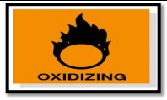

Explosive: These products may explode by the action of heat, sources of ignition, shock or friction. The compounds are often packaged wet to reduce the risk of explosion; they will become dangerous if allowed to dry. Some compounds form sensitive explosive salts on contact with metals.
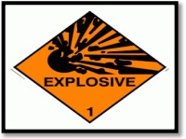
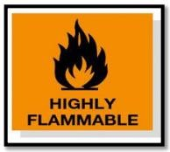


Flammable: These compounds have a low flash point, and those which react with water or damp air to give rise to flammable gases (e.g. hydrogen) from metal hydrides. Ignition sources include Bunsen burners, hot metal surfaces, electric sparks, etc. Fire fighting equipments should be readily available and frequently checked.

Harmful: Irritant chemicals cause inflammation of the skin, mucous membranes, or discomfort of the respiratory system. All laboratory chemicals should be regarded as harmful; some are specifically harmful by skin contact, inhalation or swallowing.

SYNTHESIS OF ASPIRIN

Aim: - To prepare and submit Aspirin from salicylic acid Chemicals required: - salicylic acid, acetyl chloride, Pyridine. Apparatus: - conical flask, beaker, measuring cylinder etc.,
Principle: - The principle involved in synthesis of aspirin acetylation where the hydroxylic group present in salicylic acid is acetylated by using acetyl chloride or acetic anhydride.
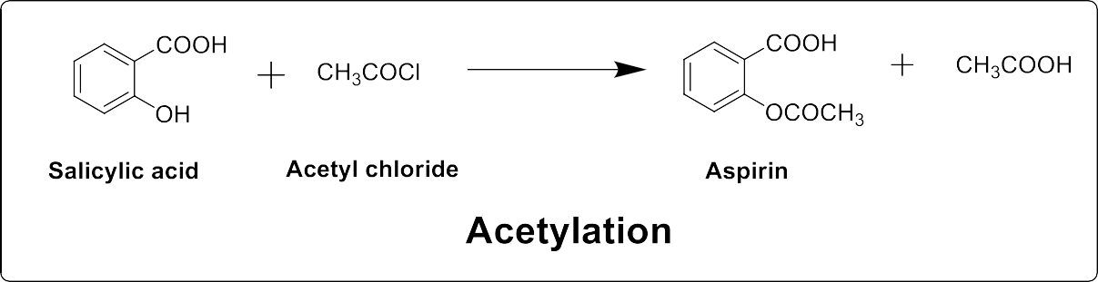

Procedure: - Dissolve 10gm of salicylic acid in 7 ml of dry pyridine containing in a 100ml of conical flask. Then without delay run in 7.5ml of acetyl chloride adding about 1ml of the chloride at time to time and shake the mixture continuously during the addition. The heat of the reaction causes the temperature of the mixture to rise. Therefore, maintain the latter between 50-60⁰c throughout the addition, cool the flask and addoccasionally cool water if necessary. Finally heat the mixture on boiling water bath for 15min and then after cooling in cold water, stirring the mixture vigorously meanwhile the crude acetylsalicylic acid either solidfy atonce are separates as an oil which rapidly crystallize as the stirring proceeds. Filter the solid product at the pump, wash thoroughly with water and drain. Recrystallize from a mixture of equal volume of water and acetic acid the acetylsalicylic acid is obtained as colourless crystals.
Report: - The Aspirin was prepared and submitted and the percentage yield was found to be

Reference: - Page. No. 111 F.G. Mann & Saunders, Practical Organic Chemistry, 4th Edition

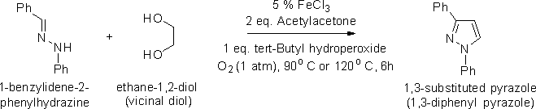
SYNTHESIS OF 1,3-SUBSTITUTED PYRAZOLE

Aim: - To prepare 1,3-diphenyl pyrazole from diphenyl hydrazone and vicinal diol.

Chemicals required: - 1-benzyledene-2-phenyl hydrazine, ethylene glycol, Ferric chloride, Tert-butyl hydroperoxide, Acetyl acetone, sodium chloride, Ethyl acetate, sodium sulphate
Apparatus: - conical flask, beaker, measuring cylinder etc.,

Principle:
1,3-substituted pyrazole is prepared by cyclization of diarylhydrazone and vicinal diol in presence of ferric chloride and tert-butylhydroperoxide(TBHP) which is also called regioselective synthesis of substituted pyrazole.

Reaction: -

Procedure: -

About 4.55g of 1-benzyledene-2-phenyl hydrazine is dissolved in the solution of 25ml of vicinal diol and ferric chloride (5mol%). Then another solution of tert-butyl hydroperoxide (5.3g) in 25ml of acetyl acetone is added into it. The mix solution is kept maintaining at a temperature range of 90-100ºC. The mix solution is left to reach room temperature and stirred for 6hrs. Then the content is pored into water and extracted with ethyl acetate 3 times. The combined organic solution is washed with water, then with a saturated solution of sodium chloride, passed through sodium sulphate and evaporated under vacuum.

Uses: -
Can be used as antibacterial and antiviral agent.

Calculation: -
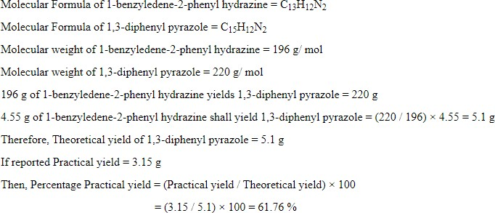

Report: -

The percentage yield of 1,3-dihenyl pyrazole is % with m.p. 185ºC

References: -

SYNTHESIS OF BENZIMIDAZOLE

Aim: Prepare and submit Benzimidazole from o-phenylenediamine. Apparatus: Beaker, conical flask, measuring jar, water bath etc., Chemicals required: o-phenylenediamine, Formic acid, NaOH
Principle: The principle involved in the synthesis of Benzimidazole is Phillips reaction involves the condensation of ortho phenylenediamines with organic acids in presence of dilute mineral acids to furnish Benzimidazoles.
Mechanism: Initially one of the amino groups is acylated with the organic acid in presence of mineral acid to furnish an N-acylated compound. In the next step, the other nitrogen is also acylated by making bond with the carbonyl carbon of the first acyl group leading to ring closure.
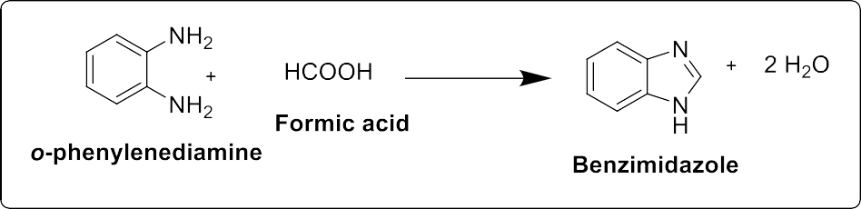
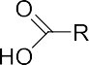
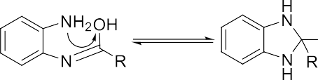


Procedure: Place 27g of o-phenylenediamine in 250 ml RBF and add 16 ml of 90% formic acid. Heat the mixture on water bath at 100⁰C for 2 hrs. Cool, add 10 % sodium hydroxide solution slowly, with constant rotation of the flask, until the mixture is just alkaline to litmus. Filter off the solid benzimidazole at the pump and wash with a little cold water. Recrystallize from hot water and dry upon hot air oven or in the air.

Report: The Benzimidazole was prepared and submitted in the laboratory and its percentage yield was found tobe
Category: Antifungal.

Reference: - Page. no. 1162, Vogel’s Practical Organic Chemistry 6th Edition

SYNTHESIS OF BENZOTRIAZOLE

AIM: To synthesize and submit benzotriazole from o-phenylene diamine and report its percentage yield.
Apparatus: Beaker, conical flask, measuring jar, water bath etc.,

CHEMICAL REQUIREMENTS: o-phenylenediamine, glacial acetic acid, sodium nitrite

PRINCIPLE:

The sodium nitrite reacts with glacial acetic acid and liberates nitrous acid. The o-phenylene diamine reacts with nitrous acid and produce diazonium ion. When the structure and stereochemistry of diazonium ion are stable, intramolecular nitrogen coupling occurs and form benzotriazole directly.

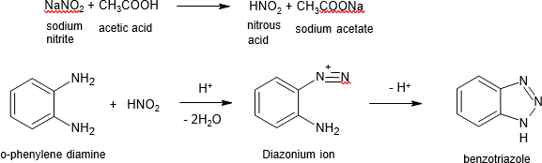

PROCEDURE:
Dissolve 1.3g of o-phenylenediamine in a mixture of 1.5ml of glacial acetic acid and 5ml water in a beaker. Stir until the solid dissolves, warm gently if necessary. Cool the solution to 15⁰C. Stir well and add a solution of 2g of sodium nitrite in 2ml water. Reaction mixture become warm within 2-3 minutes and reaches a temperature of about 85⁰C and then begins to cool. Colour changes from deep red to pale brown. Continue stirring for 15 minutes till the temperature fall about 35-40⁰C. Thoroughly chill in ice bath for 30 minutes. Filter the product and wash with cold water.

USE:

Used in bulk drug industry as an important intermediate compound.

It is the basic nucleus present in anthelmintic drugs like mebendazole, thiabendazole etc.

REPORT:
Benzotriazole was prepared and submitted. The percentage yield was found to be ---------

REFERENCE:

    - Practical medicinal chemistry by Dr. Devala Rao, page no:35.
    - Comprehensive practical organic chemistry by V.K.Ahluwalia and Renu Aggarval, page no:121.

SYNTHESIS OF 2,3-DIPHENYL QUINOXALINE

AIM: - To synthesize and submit 2,3-diphenyl quinoxaline from o-phenylenediamine and report itspercentage yield.
Apparatus: Beaker, conical flask, measuring jar, water bath etc.,

CHEMICAL REQUIREMENTS: o-phenylenediamine, benzil, rectified spirit.

PRINCIPLE:

Quinoxalines are a type of heterocyclic compounds. They are also known as benzopyrazines.

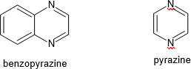

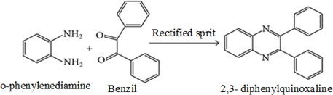
Generally, quinoxaline is formed by the condensation of o-phenylenediamine with diketones. Here 2,3-diphenyl quinoxaline is prepared by treating o-phenylenediamine with benzil.

PROCEDURE:

Add a solution of 1.1g of o-phenylenediamine in 8ml rectified spirit to a warm solution of 2.1g of benzil in 8ml rectified spirit. Warm the mixture for 30 minutes in a water bath. Add water dropwise until slight cloudiness persists. Cool the solution and filter the product.

USE:

Quinoxaline derivatives are used as antimicrobial agents like levomycin. They are also used in dyes.

CALCULATIONS:

Molecular weight of o-phenylene diamine = Molecular weight of 2, 3-diphenyl quinoxaline=
------- g of o-phenylene diamine gives g of 2, 3-diphenyl quinoxaline
1g of o-phenylene diamine =

Theoretical yield =

Practical yield =

REFERENCE:

      - Vogels textbook of practical organic chemistry,5th edition, page no:90.
      - Comprehensive practical organic chemistry by V.K.Ahluwalia and Renu Aggarwal,page no:123.

SYNTHESIS OF BENZOCAINE

Aim: To prepare and submit Benzocaine from P-amino benzoic acid.

Chemicals Required: PABA, Ethanol, Conc. H2SO4, dry HCl, Na2CO3 solution.

Principle: Aromatic esters are prepared by esterification of aromatic acids with alcohol in the presence of an Conc. H2SO4 or dry HCl which fastens the reaction. Benzocaine is an ester which was prepared by esterification of PABA with ethanol in presence of HCl.

Procedure: Place 80ml of absolute ethanol in a 250-ml two-necked flask equipped with a double surface reflux condenser and a gas inlet tube. Pass dry hydrogen chloride through the alcohol until saturated. The increase in weight is about 20gm, remove the gas inlet tube, introduce 12gm of p- aminobenzoic acid and heat the mixture under reflux for 2 hours. Upon cooling, the reaction mixture sets to a solid mass of the hydrochloride of ethyl p- aminobenzoate. It is better, however, to pour the hot solution into 30 ml of water (no hydrochloride separates) and add solid sodium carbonate carefully to the clear solution until it is neutral to litmus. Filter off the precipitated ester at the pump and dry in the air.
Report: Benzocaine was prepared and submitted in the laboratory and its percentage yield was found to be

Category: Local anaesthetic.

Reference: - Page. No. 897, Vogel’s Practical Organic Chemistry, 6th Edition

SYNTHESIS OF PHENOTHIAZINE

Aim: To Prepare and submit Phenothiazine from diphenylamine

Apparatus: Beaker, conical flask, measuring jar, water bath etc.,

Chemicals required: Diphenylamine, sulphur, anhydrous calcium chloride, alcohol

Principle:
Phenothiazine is prepared by fusing diphenylamine with sulphur with rapid evolution of hydrogen sulphide.

Reaction:

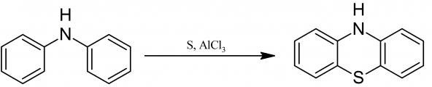

Procedure:
22 g of diphenylamine, 8.2 g of sulfur, and 3.2 gms. of anhydrous calcium chloride are melted together. The reaction sets 140-150° C with the rapid evolution of hydrogen sulfide; by lowering the temperature, a few degrees the reaction can be slackened. When the reaction has moderated, the temperature is raised to 160° C for a time. The melt, when cool, is ground up and extracted, first with water and then with dilute alcohol. The residue consists of almost pure phenothiazine. It can be recrystallized from alcohol. Yield 93%, yellowish leaflets; m.p. 180° C.
Category: Antipsychotic

Report: Phenothiazine was synthesized and the percentage yield was found to be %

Reference: - Systematic organic chemistry, by W. M. Cumming, 325-326, 1937.

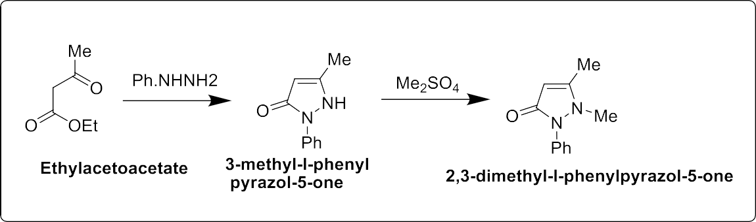
SYNTHESIS OF ANTIPYRINE

Aim: - To prepare and submit Antipyrine from Phenyl hydrazine.

Apparatus: - RBF, Beaker, Measuring cylinder, Reflux condenser, Water bath, Funnel, Heating mantel, funnel etc.,
Chemicals Required: - Phenyl hydrazine, ethyl acetoacetate, dimethyl sulphate, Pet.ether, ethanol, sodium hydroxide, decolourising carbon.
Principle: - The basic nitrogen atom attached to the phenyl ring in the Phenyl hydrazine reacts with ethyl acetoacetate to undergoes cyclization by the removal of ethanol and water molecule. Later the hydrogen attached to the adjacent nitrogen undergoes methylation in presence of dimethyl sulphate to yield Anti-pyrine.

Procedure: -Mix together 50g (49ml,) of redistilled ethylacetoacetate and 40g (36.5ml,) of phenylhydrazine (CAUTION in handling) in a large evaporating dish. Heat the mixture on a boiling water bath in the fume cupboard for about 2 hours and stir from time to time with a glass rod. Allow the heavy reddish syrup to cool somewhat, add about 100ml of ether and stir the mixture vigorously. The syrup, which is insoluble in ether, will solidify within15 minutes. Filter the solid at the pump and wash it thoroughly with ether to remove coloured impurities. Recrystallise it from hot water or from a mixture of equal volumes of ethanol and water.

Formation of 2,3-dimethyl-l-phenylpyrazol-5-one by N-methylation.

In a 500-ml three-necked flask, equipped with a dropping funnel, a sealed stirrer unit and a double surface condenser and setup in the fume cupboard, place a solution of 10g of sodium hydroxide in a small volume of water and also a solution of 43.5g(0.25mol) of 3-methyl-l-phenylpyrazol-5-one in 20ml of methanol. Warm the mixture on a water bath and add 36g (27ml,) of dimethyl sulphate (CAUTION: toxic,). Reflux the mixture for 1hour and allow to cool, with continuous stirring. Distil
off the methanol. Add hot water to the residue, filter from impurities, extract the antipyrine with benzene (fume cupboard) and evaporate the solvent. Recrystallise the crude product from benzene (CAUTION) or benzene-light petroleum, or from hot water with the addition of a little decolourising carbon. The yield of antipyrine (white crystalline solid)
Category: - Anti-pyretic.

Report: - Antipyrine was prepared and submitted in the laboratory and its percentage yield was found to be

Reference: - Page. No. 1150 Vogel’s Practical Organic Chemistry, 6th Edition

SYNTHESIS OF 5,5-DIPHENYHYDANTION

Aim: - To prepare and submit 5,5-Diphenylhydantoin from Benzil.

Apparatus: - RBF, Beaker, Measuring cylinder, Reflux condenser, Water bath, Funnel, Heating mantel etc.,

Chemicals Required: - Benzil, Urea, Sodium Hydroxide, Ethanol, Hydrochloric Acid.

Principle:- The principle involved in this reaction is Pinacol-Pinacolone rearrangement which is a is a method for converting a 1,2-diol to a carbonyl compound called Pinacol which later undergoes a rearrangement and dehydration to form a monoketone called Pinocolone. In this reaction aromatic diketone Benzil reacts with urea to form a pinacol. Later this undergoes rearrangement to form pinacolone nothing but 5,5-Diphenylhydantoin (Phenytoin).
Mechanism: -This reaction mechanism involves the three steps.

- Protonation of 1,2-diol

- Generation of Carbonium ion by loss of water molecule

- 1,2- shift of alkyl group to form a ketone

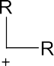
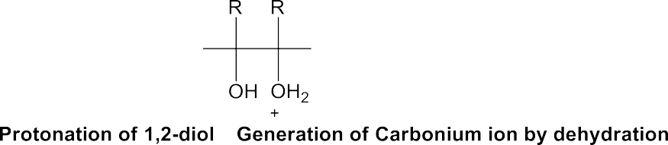
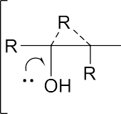
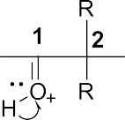

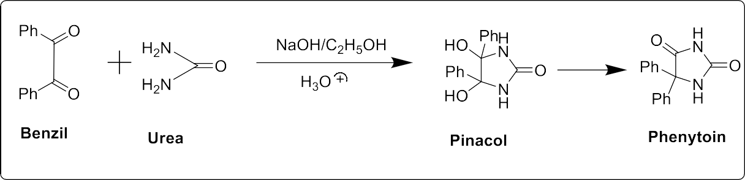

Procedure: - Place 5.3g (0.025mol) of benzil,3.0g of urea,15ml of 30 percent aqueous sodium hydroxide solution and 75ml of ethanol in a 100-ml round-bottomed flask. Attach a reflux condenser and boil under reflux using an electric heating mantle for at least 2 hours. Cool to room temperature, pour the reaction product into125ml of water and mix thoroughly. Allow to stand for 15minutes and then filter under suction to remove an insoluble by-product. Render the filtrate strongly acidic with concentrated hydrochloric acid, cool in ice-water and immediately filter off the precipitated product under suction.
Category: - Anti- Epileptic.

Report: - 5,5-Diphenylhydantoin was prepared and submitted in the laboratory and its yield was found to be

Reference: - Page. No. 1153 Vogel’s Practical Organic Chemistry, 6th Edition

SYNTHESIS OF BARBITURIC ACID

Aim: - To prepare barbituric acid from urea and dimethyl malonate.

Apparatus: - RBF, Beaker, Measuring cylinder, Reflux condenser, Water bath, Funnel, Heating mantel etc.,

Chemicals Required: - Sodium metal, Ethanol, Diethyl malonate, Urea, Calcium chloride, conc. HCl

Principle: -

The synthesis of barbituric acid is affected by condensation of diethyl malonate with urea in the presence of sodium ethoxide which may be prepared by reacting sodium metal with ethanol and it undergo cyclization reaction with diethyl malonate.

Reaction: -
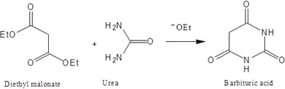

Mechanism: -

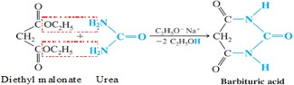

Procedure: -

Assemble a double surface reflux condenser with a 2 litre round bottomed flask, place 11.5g (0.5 mol) of clean sodium. Mix 250ml of absolute ethanol in a portion and if the reaction is unduly
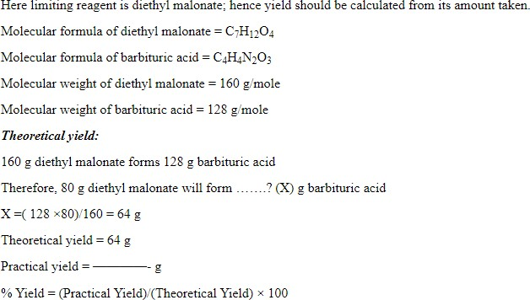
vigorous, immerse the flask within ice. When all the sodium has completed reaction, add diethyl malonate 80g (76ml, 0.5 mol), followed by a solution of dry urea 30g (0.5 mol) in 250ml of hot (70ºC) absolute ethanol. Shake the mixture thoroughly, attach a calcium chloride guard tube to the top of the condenser, start reflux of the mixture for 7hr in an oil bath and heat to 110ºC. A white solid will be separated. Treat the reaction mixture with hot (50ºC) water 450ml and then with conc HCl, with constant stirring, until the solution will be acid (about 45ml). Filter the resulting almost clear solution and leave it in the refrigerator overnight. Filter the solid at the pump, wash it with 25ml of col water, drain well and then dry at 100ºC for 4 hours.

Use: -

Itself not active pharmacologically, but its derivatives are used as sleeping pills and sedatives.

Calculation: -

Report:

Barbituric acid was synthesized and the percentage yield was found to be _ %
References: -
ASSAY OF CHLORPROMAZINE

AIM: To carry out the Assay of Chlorpromazine.
Apparatus: - Erlenmeyer flask, Volumetric flask, Pipette, Burette etc.,

Chemicals Required:

Perchloric acid (0.1M), Chlorpromazine, mercuric acetate solution (5% w/v in acetic acid), crystal violet solution (0.2%w/v in acetic acid), acetone, methyl orange indicator, potassium hydrogen phthalate, glacial acetic acid, crystal violet indicator.

PRINCIPLE:

Chlorpromazine is estimated by non-aqueous titration which is suitable for titration of weak acid and weak base. In this non aqueous solvent like perchloric acid is utilized as a titrant and methyl orange is used as an indicator. Mercuric acetate is added in the non-aqueous titration in order to remove the chloride ions. So as to prevent the interference of the chloride ion released by the titrant. The mercuric acetate replaces the halide ion in chlorpromazine with acetate ion which is a strong base. The end point is indicated by appearance of blue colour.

PROCEDURE:

  - STANDARDISATION OF PERCHLORIC ACID (0.1N)

Dissolved 0.5g of potassium hydrogen phthalate in 25ml of glacial acetic acid and added few drops of 5%w/v crystal violet indicator. Titrated the solution with 0.1N perchloric acid till blue green colour appears.

ASSAY OF CHLORPROMAZINE
Weighed accurately about 0.6g and dissolved in 200 ml of acetone. Added 15ml of mercuric acetate solution. Titrated with 0.1M perchloric acid, using a saturated solution of methyl orange in acetone as indicator. Perform a blank determination and make a necessary correction.
Each ml of 0.1M perchloric acid equivalent to 0.03553g of C17H19ClN2S,HCl

REPORT:

The given sample contains mg of chlorpromazine.

REFERENCE: Indian Pharmacopoeia 2018-page no:1600-01.
ASSAY OF PHENOBARBITONE
AIM: To perform the Assay of Phenobarbitone.

Apparatus: - Erlenmeyer flask, Volumetric flask, Pipette, Burette etc.,

Chemicals Required: - Sodium hydroxide, aldehyde free ethanol, benzoic acid, thymolphthalein solution, silver nitrate, pyridine and ether

Principle: - Phenobarbitone is assayed by non-aqueous titration. In this method, drug is dissolved in the pyridine and titrated with sodium hydroxide solution using thymolphthalein as an indicator.

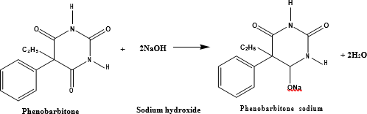

PROCEDURE:

- STANDARDISATION OF SODIUM HYDROXIDE SOLUTION

Actually weighed 0.6g of benzoic acid and dissolved it in a mixture of 30ml of ethanol and 6ml of water and titrated with ethanolic sodium hydroxide solution using 0.2ml of thymolphthalein as indicator.

ASSAY OF PHENOBARBITONE

Weighed and powdered 20 tablets. Weighed a quantity of the powder containing about0.1g (100 mg) of phenobarbitone in 5ml of pyridine add 0.25 ml of thymolphthalein solution and 10 ml of silver nitrate pyridine reagent and titrated with 0.1M ethanolic sodium hydroxide until a pure blue colour is obtained. Repeated the operation without the substance under examination. The difference between the titrations represents the amount of sodium hydroxide required.
Equivalent factor: 1ml of 0.1M ethanolic sodium hydroxide=0.01161g of C12H12N2O3

CALCULATION

  - Standardization of 0.1M Sodium hydroxide solution

Molarity of NaOH= Weight (W)
Mol. wt of benzoic acid (122.12) X Volume (V)
Where,

W = Weight of benzoic acid (g)

V = Volume of NaOH solution consumed

a) Determination of Phenobarbitone

% purity of phenobarbitone = 0.01161 x V X Molarity (Calculated) x 100
Molarity (given) x W

Where,

Molarity (calculated) = Molarity obtained from step (a) V = Volume of Sodium hydroxide used
0.01161 is the equivalent factor Molarity (given) = 0.1M
W = weight of sample

REPORT

The percentage purity of Phenobarbitone was found to be =

REFERENCE:

- A textbook of Medicinal Chemistry-I,Pragi Arora, Varun Arora, Davinder Kumar, Pageno:282,283.
- Indian Pharmacopoeia Volume III 2018, Page No:2899,2900.
ASSAY OF ATROPINE
AIM: To perform the Assay of Atropine.

Apparatus: - Erlenmeyer flask, Volumetric flask, Pipette, Burette etc.,

Chemicals Required: - Perchloric acid (0.1M), atropine, glacial acetic acid, crystal violet solution (0.2%w/v in aceticacid), acetone, methyl orange indicator

PRINCIPLE:

Atropine is assayed by non-aqueous titration which is generally used for the titration of weakacid with weak base. In this titration non-aqueous solvent perchloric acid is used and crystal violet is used as an indicator. At the end point blue colour is obtained.

PROCEDURE:

- STANDARDISATION OF PERCHLORIC ACID (0.1N)

Dissolved 0.5g of potassium hydrogen phthalate in 25ml of glacial acetic acid and few dropsof 5%w/v crystal violet indicator. Titrated the solution with 0.1N perchloric acid till blue green colour appears.

ASSAY OF ATROPINE

Weighed accurately 400mg of atropine and dissolved it in 50ml of glacial acetic acid and added a drop of crystal violet indicator. Titrated this solution with 0.1N perchloric acid until green color is obtained end point.

Report: - The percentage purity of Atropine was found to be

Reference: -

  - Indian Pharmacopoeia 2018-page no:1600-01.

  - A textbook of Medicinal Chemistry-I,Pragi Arora, Varun Arora, Davinder Kumar, Pageno:281,282

ASSAY OF IBUPROFEN

Aim: - To determine percentage purity of Ibuprofen.

Apparatus: - Erlenmeyer flask, Volumetric flask, Pipette, Burette etc.,

Chemicals Required: - Ibuprofen, sodium hydroxide, Potassium hydrogen pthallate, Phenolpthalein indicator,Phenol red etc.,
Principle: - The principle involoved in the assay of Ibuprofen is acid-base titration where the acidic group in Ibuprofen is neutralized by titrating with base i.e. NaOH using phenolphthalein as an indicator where the end point is colourless to pink.
Procedure: -

Standardization of 0.1 M NaOH:

Weigh about 0.5gm of KHP into 250-mL Erlenmeyer flask which was previously powdered and dried at 110⁰C. Dissolve the sample in about 30 mL of distilled water before you titrate. Add five drops of phenolphthalein indicator and titrate with 0.1M NaOH by constant swirling to the first appearance of a permanent pink color.
Each mL of 0.1M NaOH is equivalent to 0.02042gm of C8H5KO4.

Assay: Weigh accurately about 0.5gm of drug and dissolve in 100ml of ethanol (95%) and titrate with a 0.1m NaOH using phenolphthalein as an indicator where the end point is permanent pink colour. Repeat the titration with blank.
Each mL of 0.1M NaOH is equivalent to 0.02663gm of C13H18O2. Percentage purity = x 100
Titre value x molarity of NaOH x Eq. factor
Weight taken x expected molarity

Report: - The percentage purity of Ibuprofen was found to be

Reference: - Page. No. 388, Volume: I, Indian Pharmacopiea (1996)

ASSAY OF ASPIRIN

Aim: - To determine percentage purity of Aspirin.

Apparatus: - Erlenmeyer flask, Volumetric flask, Pipette, Burette etc.,

Chemicals Required: - Aspirin, sodium hydroxide, Potassium hydrogen phthalate, Phenolphthalein indicator,Phenol red etc.,
Principle: - The principle involved in the assay of Aspirin is acid base titration where the acidic group in aspirinis neutralized by titrating with base i.e. NaOH and the excess base is back titrated with an acid (HCl) using phenol red as an indicator where the end point is pink to colourless.
Procedure: -

Standardization of 0.5 M NaOH: -

Weigh about 2.5gm of KHP into 250-mL Erlenmeyer flask which was previously powdered and dried at 110⁰C. Dissolve the sample in about 30 mL of distilled water before you titrate. Add five drops of phenolphthalein indicator and titrate with 0.5M NaOH by constant swirling to the first appearance of a permanent pink color.
Each mL of 0.5M NaOH is equivalent to 0.1021gm of C8H5KO4.

Standardization of 0.5M HCl: -

Pipette out 20 mL of 0.5m NaOH solution into 250mL Erlenmeyer flask and add five drops of phenolphthalein indicator and titrate with 0.5M HCl by constant swirling to the disappearance of pink color.
Assay: Weigh accurately about 0.5 gm of sample dissolved in 15m: of ethanol (95%), add 50mL of 0.5M NaOH. Boil gently for 10 minutes, cool and titrate the excess alkali with 0.5M HCl using Phenol red as an indicator. Repeat the titration with blank.
Each mL of 0.5M HCl is equivalent to 0.04504gm of C9H7O4.

Percentage purity= x 100
Titre value x molarity of HCl x Eq.factor

Weight taken x expected molarity

Report: - The percentage purity of Aspirin was found to be

Reference: - Page. No. 70 Volume: I Indian Pharmacopeia (1996)
ASSAY OF FUROSEMIDE
AIM: To carry out the Assay of furosemide tablets.

Apparatus: - Erlenmeyer flask, Volumetric flask, Pipette, Burette etc.,

Chemicals Required: - Furosemide, dimethyl formamide, sodium hydroxide, bromothymol blue indicator,0.1N oxalicacid, Phenolphthalein indicator

PRINCIPLE

It is assayed by aqueous acid base titration between weak acid furosemide and strong alkali sodium hydroxide. In this assay protophilic solvent dimethyl formamide is used which enhances the acidity of furosemide so that it can be titrated with sodium hydroxide. To makethe effect of acid impurities present negligible a solvent blank determination is carried out.

PREPARATION AND STANDARDIZATION OF STANDARD SOLUTIONS

- SODIUM HYDROXIDE, XM

Solutions of any molarity xM may be prepared by dissolving 40x g of Sodium hydroxide in sufficient water to produce 1000ml.

STANDARDIZATION OF 0.1M SODIUM HYDROXIDE SOLUTION

Weighed accurately about 5g of potassium hydrogen phthalate previously dried at 120⁰C for two hours dissolve in 75ml of carbon dioxide free water. Added 0.1ml of phenolphthalein solution and titrate with the sodium hydroxide until a permanent pink color is produced.
Each ml of 0.1M NaOH equivalent to 0.02042g of potassium hydrogen phthalate.

PROCEDURE:

- ASSAY METHOD BY (NEUTRALIZATION TITRATION)
Weighed and powdered 20 tablets and weighed accurately about a quantity of powder equivalent to 0.5g and dissolve in 40ml of dimethyl formamide and titrate with 0.1M sodium hydroxide using bromothymol blue as an indicator the end point shows the colour change from yellow to blue. Carry out a blank titration.

ASSAY METHOD BY (UV SPECTROPHOTOMETRY)
Weighed and powdered 20 tablets and weigh accurately about a quantity of powder equivalent to 0.1g of furosemide and shake with 150ml of 0.1M sodium hydroxide for 10 minutes. Added sufficient 0.1M sodium hydroxide to produce 250ml and filter. Dilute 5ml to200ml with 0.1M
sodium hydroxide and measure the absorbance of the resulting solution at the maximum at

about 271nm.Calculate the content of C12H11 ClN2O5S taking 580 as the value of A (1%, 1cm) at the maximum at about 271 nm.

REPORT:

The given sample contains mg of furosemide.

REFERENCE:

  - A textbook of Medicinal Chemistry-I,Pragi Arora, Varun Arora, Davinder Kumar, Pageno:288,289.
  - Indian Pharmacopoeia Volume III 2018, Page No:2899,2900.

ASSAY OF SULPHAMETHOXAZOLE

Aim: - To determine percentage purity of Sulphamethoxazole.

Apparatus: - Erlenmeyer flask, Volumetric flask, Pipette, Burette etc.,

Chemicals Required: - Sulphamethoxazole, Sulphanilic acid, Sodium nitrite, Potassium bromide, Hydrochloricacid, Starch iodide external indicator.
Principle: - The principle involved in the assay of Sulphamethoxazole is diazotization where the Sodium nitrite consumed by sulphamethoxazole to form diazonium salt is calculated by using starch iodide as an external indicator which gives blue colour as an end point.

Procedure: - Standardization of 0.1 M NaNO2:-

Weigh about 0.3gm of sulphanilic acid and dissolve in 50-ml of 2M HCl. Add 3g of Potassium bromide, cool in ice and titrate with 0.1M NaNO2 solution using starch iodide as an external indicator which gives blue colour as an end point.
Each mL of 0.1M NaNO2 is equivalent to 0.01732 gm of Sulphanilic acid.

Assay: Weigh accurately about 0.2 gm of sample dissolved in 50 ml of 2M HCl. Add 3gm of potassium bromide, cool in ice and titrate against 0.1 M NaNO2 using starch iodide as an indicator. Repeat the titration with blank.
Each mL of 0.1M NaNO2 is equivalent to 0.02533gm of C10H11N3O3S.

Percentage purity=
Titre value x molarity of NaNO2 x Eq.factor
x 100

Weight taken x expected molarity

Report: - The percentage purity of Sulphamethoxazole was found to be

Reference: - Page. No.1145 Volume: III Indian Pharmacopeia (2007)

DETERMINATION OF PARTITION COEFFICIENT OF BENZOIC ACID BETWEEN BENZENE AND WATER

AIM: -
To determine partition coefficient of benzoic acid between benzene and water.

REFERENCE:
- Medicinal chemistry – I, Mrs Sheethal V.Patil, Mrs.Swati G.Patil, Dr.Sunila T.Patil, Dr. Md. Rageeb, Md. Usman page no:270-272.
- Textbook of Practical chemistry 2008, K.S mukherjee, Page no:293.

REQUIREMENTS:

Separating funnel(250ml), conical flask, pipette, burette, stoppered bottle, Saturated solution of benzoic acid in benzene, benzene,0.01N NaOH, 0.1N NaOH and distilled water.

PRINCIPLE:
When a solute is shaken with two immiscible solvents it gets distributed between the solvents. This distribution of solute in two solvents depends on the solubility of the solute in two solvents. At the distribution equilibrium, the ratio of concentration of the solute in the two solvents is constant at a given temperature. The constant is called partition coefficient (K) or the distribution coefficient of the solute between the two solvents.

PROCEDURE:

Prepared the following mixtures in separating funnels:

Set I: 25ml water + 25ml of saturated solution of benzoic acid in benzene.

Set II: 25ml water + 20 ml saturated solution of benzoic acid in benzene + 5ml benzene. Set III: 25ml water + 15ml saturated solution of benzoic acid in benzene + 10ml benzene.
Shaken the mixture in the separating funnel vigorously for about 30 minutes so that the benzoic acid gets distributed between the two solvents and the distribution equilibrium is reached. Allowed the flasks to stand for 10 minutes to separate into two clear layers (removedthe stopper of the separating funnel and keep its mouth open during this period to facilitate theseparation). Drain off the lower aqueous layers in 3 different stoppered dry bottles. (Discard the intermediate layer between the two phases). Benzene layer remains in the separating funnels. Using a dry pipette take 5ml of organic layer (Benzene) into a conical flask containing 10ml of water and
titrate against 0.1N NaOH using Phenolphthalein as an indicator. The end point is indicated by the color change from colorless to pink. Pipette out 10ml of the aqueous layer using dry pipette and titrate it against NaOH solution using phenolphthalein as an indicator. End point is indicated by the color change from colorless topink.

OBSERVATION

Set No. | Vorg | Vaq | Norg = Corg | Naq = Caq | K | logCorg | log Caq

Mean partition coefficient (K) = Where,
Vorg = Volume in ml of 0.1N Sodium hydroxide per 5ml of organic layer Vaq = Volume in ml of 0.1N Sodium hydroxide per 5ml of aqueous layer Norg = Normality of organic layer
Naq = Normality of aqueous layer

Corg = Concentration of organic layer in g mole/lit Caq = Concentration of aqueous layer in g mole/lit
K = Caq/ (Corg)1/2 = Partition coefficient of benzoic acid in water and benzene

CALCULATIONS

Set I:

For organic layer

Normality of NaOH (N1=0.1N)

Volume of Organic layer pipetted (V2) = 5ml N1V1 (Sodium hydroxide) = N2V2 (Organic layer)
N2 = 0.1 X V1 = Norg 5
Similarly calculate concentration of benzoic acid in organic layer of sets II and III

For aqueous layer

Normality of NaOH (N1=0.01N)

Volume of aqueous layer pipetted (V2) = 5ml N1V1 (Sodium hydroxide) = N2V2 (aqueous layer) N2 = 0.1 X V1 = Naq
5

Similarly calculate concentration of benzoic acid in aqueous layer of sets II and III

Graph

Plot the graph of logCaq Vs logCorg Partition coefficient (K) = Caq
Corg1/2 log Caq = 1/n log Corg + log K
Above equation is equation of a straight line (y = mx +c)

Result from graph Slope (m) =1/n Therefore, n is nearly =
Substituting the value of slope of line in the equationlog Caq = 1/n log Corg + log K
log Caq = log Corg + log K log K =
K =
REPORT:
- Partition coefficient of benzoic acid between distilled water and benzene is………………….. by calculation and by graph.
- Since Caq/ Corg ½ is practically constant benzoic acid exists as a dimer (n=2) inbenzene.
- Molecular condition of benzoic acid in benzene is 1/slope = n
= ,molecules of benzoic acid associate in benzene.

DETERMINATION OF PARTITION COEFFICIENT

