INSTRUMENTAL METHODS OF ANALYSIS
LAB MANUAL

R17 B. PHARMACY IV YEAR

PS709: INSTRUMENTAL METHODS OF ANALYSIS LAB

B.Pharm. IV Year I Sem. L/T/P/C
0/0/4/ 2

List of Experiments:
- Determination of absorption maxima and effect of solvents on absorption maxima of organic compounds
- Estimation of dextrose by colorimetry
- Estimation of sulfanilamide by colorimetry
- Simultaneous estimation of ibuprofen and paracetamol by UV spectroscopy
- Assay of paracetamol by UV- Spectrophotometry
- Estimation of quinine sulfate by fluorimetry
- Study of quenching of fluorescence
- Determination of sodium by flame photometry
- Determination of potassium by flame photometry
- Determination of chlorides and sulphates by nephelo turbidometry
- Separation of amino acids by paper chromatography
- Separation of sugars by thin layer chromatography
- Separation of plant pigments by column chromatography
- Demonstration experiment on HPLC
- Demonstration experiment on Gas Chromatography

Recommended Books (Latest Editions):
- Instrumental Methods of Chemical Analysis by B.K Sharma
- Organic spectroscopy by Y.R Sharma
- Text book of Pharmaceutical Analysis by Kenneth A. Connors
- Vogel’s Text book of Quantitative Chemical Analysis by A.I. Vogel
- Practical Pharmaceutical Chemistry by A.H. Beckett and J.B. Stenlake
- Organic Chemistry by I. L. Finar
- Organic spectroscopy by William Kemp
- Quantitative Analysis of Drugs by D. C. Garrett
- Quantitative Analysis of Drugs in Pharmaceutical Formulations by P. D. Sethi
- Spectrophotometric identification of Organic Compounds by Silverstein

1. SEPARATION AND IDENTIFICATION OF AMINO ACIDS BYASCENDING PAPER CHROMATOGRAPHY
Aim: To separate and identify the given amino acids by Ascending Paper Chromatography.

Apparatus and glass ware: Chromatographic chamber, spraying gun, capillary tubes and whatman grade filter paper
Chemicals:

Solvent System: N-butanol, Acetic acid and Water

Visualizing Agent: Ninhydrin solution

Standard references: Aminoacids

Principle:

The principle involved is partition, where the substances are distributed or partitioned between to liquid phases. One phase is the water which is held in pores of filter paper used and other phase is that of mobile phase which moves over the paper. The compounds in the mixture get separated due to differences in their affinity towards water (in stationary phase) and mobile phase during the movement of mobile phase under the capillary action of pores in the paper
The principle can also be adsorption chromatography between solid and liquid phases, where in the stationary phase is the solid surface of paper and the liquid phase is of mobile phase. But most of the applications of paper chromatography work on the principle of partition chromatography
i.e. partitioned between to liquid phases. Identification of amino acids in the given mixture is determined by Rf value
Rf

Rf value is less than one for all compounds.

Preparation of solutions:

Solution A: 0.1 gm of Methionine in required quantity of suitable solvent

Solution B: 0.1 gm of Valine in required quantity of suitable solvent Solution C: 0.1 gm of in required quantity of suitable solvent Solution D: unknown mixture
Mobile phase: N-butanol : Acetic acid : Water ( 4 : 1 : 5 ) Ninhydrin Solution: 0.2% (200mg in 100ml of N-butanol)
Procedure:

  - Preparation of mobile phase: 40 ml of N-butanol, 10 ml of acetic acid and 50 ml of water were taken in a beaker and mixed well.
  - Preparation of sample:0.1 gm of ariginine,0.1 gm of valine and 0.1 gm of methionine were taken separately and dissolved in required quantity of ethanol .
  - Application of sample: One drop of individual sample solutions were applied to chromatographic paper with capillary tube.

Procedure of development of chromatogram

- Take a whatman filter paper and draw a thin straight line of about 2cm from the bottom of the paper.
- Mark four points with equidistance on the straight line and number them.
- Prepare sample solutions and place a drop of these solutions on the straight line by using capillary tube.
- Hang the chromatographic paper in chamber containing mobile phase, Run the chromatogram till the mobile phase travels on ¾^{th} of the chromatographic paper.
- Remove the paper from the chamber and mark the solvent distance with a pencil and dry in air for 15 minutes
- Now spray ninhydrin solution to the chromatogram and dry it in oven for 10-15 minutes
- Measure the distance of purple colour spots from the baseline and also the distance of travelled by mobile phase.
- Calculate the Rf values for the identification of amino acids in the given mixture.

Rf = Distance travelled by solute/ Distance travelled by solvent

Observation:

S.No | Aminoacid | Distance travelled By amino acid | Distance travelled By solvent front | Rf value

Report:

The Rf values of standard or reference samples are: Arginine :
Valine:

Methionine:

Rf Vlues of amino acids in the mixture are: 2. Based on the Rf Values , the mixture was found
Questions

- Give the name and composition of mobile phase?

- What is Retention factor and write the formula for Retention factor?

- What are the units of Rf value ?

- How do you detect amino acids in chromatography?

- What is the principle involved in paper chromatography?

SEPARATION AND IDENTIFICATION OF AMINO ACIDS BY RADIAL PAPER CHROMATOGRAPHY

Aim: To separate and identify the given amino acids by Radial Paper Chromatography.

Apparatus and glass ware: Chemicals: : Chromatographic chamber, spraying gun, capillary tubes and whatman grade filter paper
Chemicals:

Solvent System: N-butanol, Acetic acid and Water (BAW System) Visualizing Agent: Ninhydrin solution
Standard references: Aminoacids

Principle:

The principle involved is partition .where in the substances are distributed or partitioned between to liquid phases. One phase is the water which is held in pores of filter paper used and other phase is that of mobile phase which moves over the paper. The compounds in the mixture get separated due to differences in their affinity towards water (in stationary phase) and mobile phase during the movement of mobile phase under the capillary action of pores in the paper
The principle can also be adsorption chromatography between solid and liquid phases, where in the stationary phase is the solid surface of paper and the liquid phase is of mobile phase. But most of the applications of paper chromatography work on the principle of partition chromatography

i.e. partitioned between to liquid phases. Identification of amino acids in the given mixture is determined by Rf value.
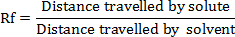

Rf value is less than one for all compounds.

Preparation of solutions:

Solution A: 0.1 gm of Methionine in required quantity of suitable solvent Solution B: 0.1 gm of Valine in required quantity of suitable solvent Solution C: 0.1 gm of Methionine in required quantity of suitable solvent Solution D: unknown mixture
Mobile phase: N-butanol : Acetic acid : Water ( 4 : 1 : 5 ) Ninhydrin Solution: 0.2% (200mg in 100ml of N-butanol)

Procedure:

  - Preparation of mobile phase: 40 ml of N-butanol, 10 ml of acetic acid and 50 ml of water were taken in a beaker and mixed well.
  - Preparation of sample:0.1 gm of ariginine,0.1 gm of valine and 0.1 gm of methionine were taken separately and dissolved in required quantity of ethanol .
  - Application of sample: One drop of individual sample solutions were applied to chromatographic paper with capillary tube.

Procedure of development of chromatogram

  - Take a Whatman filter paper and draw a round circle in the middle of paper and make a wick exactly in the centre of the circle.
  - Mark four points with equidistance on the circle line and number them.
  - Prepare sample solutions and place a drop of these solutions on the points using capillary tube.
  - Dip the wick of chromatographic paper in chamber containing mobile phase.
  - Run the chromatogram till the mobile phase travels ¾^{th} of the chromatographic paper.
  - Remove the paper from the chamber and mark the distance travelled by solvent with a pencil and dry in air for 15 minutes
  - Now spray ninhydrin solution to the chromatogram and dry it in oven for 10-15 minutes
  - Measure the distance of purple colour spots, from the baseline and also the distance of travelling of mobile phase.
  - Calculate the Rf values for the identification of amino acids in the given mixture. Rf = Distance travelled by solute/ Distance travelled by solvent

Observation:

S.No | Aminoacid | Distance travelled By amino acid | Distance travelled By solvent front | Rf value

Report:

The Rf values of standard or reference samples are: Arginine :

Valine:

Methionine:

Rf Vlues of amino acids in the mixture are Based on the Rf Values , the mixture was found
Questions

- What is the difference between partition and adsorption chromatogarphy?

- Give the name and composition of mobile phase?

- What are the different development technique in paper chromatogarphy?

- Discuss applications of paper chromatography techniques ?

SEPARATION AND IDENTIFICATION OF ALKALOIDS BY THIN LAYER CHROMATOGRAPHY
Aim: To separate and identify alkaloids by thin layer chromatography

Apparatus and chemicals: Chromatographic chamber, TLC plates, capillaries, dryer, spray gun

Adsorbent: Silica gel G

Mobile phase: Methanol, Ammonia

Visualizing agent: Dragendroff’s reagent

Standard references: Ephedrine, Atropine and Quinine

Principle:

TLC is based on the principle of adsorption. The stationary phase used in TLC is adsorbents like silica gel coated onto a inert solid support such as glass plate, mobile phase is either single solvent or mixture of solvents based on the chemical nature of sample i.e. polarity . Sample should be dissolve in mobile phase. Silicagel contains some free Si-OH groups these groups form hydrogen bonds or other vanderwaal interactions with the analyte components, thus adsorption takes place. Identification of amino acids in the given mixture is determined by Rf value.
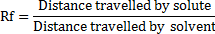

Perpration of solutions:

Solution A: 0.1 g of Atropine in required quantity of ethanol Solution B: 0.1 g of Quinine in required quantity of ethanol Solution C: 0.1 g of A & B
Mobile phase: Methanol: Ammonia(200: 3) Visualizing Agent: Dragendroff’s reagent Procedure:
- Preparation of mobile phase: Take 200 ml of methanol and 3 ml of ammonia in a beaker and mix well, keep a side for 20-30 min to get saturation of mobile phase

- Preparation of sample: Take 0.1 g of ephedrine, 0.1 g of atropine and 0.1 g of quinine in individual separate volumetric flasks and dissolved in required quantity of methanol.

- Application of sample: Make a straight horizontal line 1cm above from the bottom of TLC plate. Apply one drop of individual sample solutions to respective spots on TLC plate with capillary tube.

Procedure for development of TLC plate

  - Sample solutions are spotted on the plate by using capillary tubes. After drying of spots TLC plate has to dip in the development chambers which contain mobile phase.

Note: Dip the plate in such a way that the straight line on the TLC plate should not be immersed.
  - Remove the plate from the chamber and mark the distance travelled by solvent with a pencil and dry in air for 5 minutes
  - The sample s were visualized using Dragendroff’s reagent after getting the solvent front.
  - TLC plates were dried in an oven to visualize the samples
  - The Rf values were measured and reported.
Report: The Rf values of standard reference samples are: Ephedrine
Atropine:

Quinine:

Rf values of alkaloids in the mixture are: 1. 2.

Based on the Rf Values , the mixture was found to contain and

Questions

- Write the principle for Thin layer Chromatography.
- Writ the chemicals and reagents required for Thin layer chromatography.
- Write the adsorbents required for preparation of TLC plates.
- Write the visualizing agent & mobile phase required for TLC
- Discuss the applications of TLC.

- What are the other methods to detect the spots.

4. HIGH PERFORMANCE LIQUID CHROMATOGRAPHY

It is a technique in analytical chemistry used to separate the components in a mixture, to identify each component, and to quantify each component. The placement(injection) of a small volume of a liquid sample into a tube packed with porous particles(stationary phase).Where individual components of a sample are transported along the column by a liquid moved by pressure. This is called High Performance Liquid Chromatography as this technique is simple and able to detect components at nanogram level.
It is also called High Pressure Liquid Chromatography as mobile phase is pumped with high pressures
Principle involved in separation by HPLC

- The separation of compounds is due to their relative differences in travel through the column on application of pressure exerted through mobile phase or carrying liquid
- The compounds of the mixture travel with different rates due to their relative affinities with the solvent and stationary phase.
- Compound with higher affinity towards stationary phase of the column travels slowly and vice-versa.
- The above principle is similar to that of column chromatography but in HPLC, the separation is more effective due to greater surface area achieved due to very small particle size of stationary phase in comparison to that used in column chromatography.
Types of HPLC techniques

Based on modes of chromatography

- Normal phase : Stationary phase is polar, mobile phase is non polar
- Reverse phase: Stationary phase is non polar, mobile phase is polar Different columns used include ODS,C18,C8
Based on elution technique

- Isocratic separation: Polarity of mobile phase is same in entire procedure
- Gradient separation: Polarity of mobile phase is gradually increasing, to get better separation.
Components of HPLC system

  - Mobile phase reservoirs

  - Degassing units

  - HPLC Pumps

  - Mixing valves

  - Sample injector (manual or auto)

  - Guard columns

  - Column

  - Column ovens

  - Detector

  - Recorder and integrator

  - Mobile phase waste container

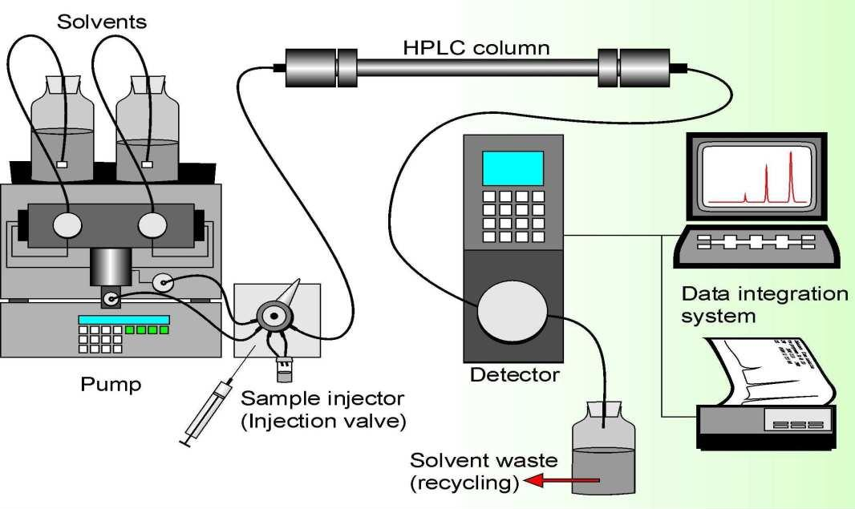

BLOCK DIAGRAM OF HPLC

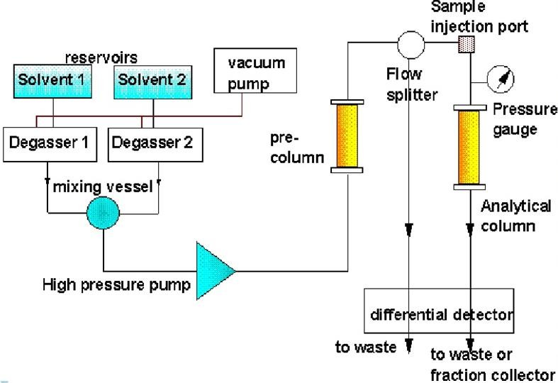

Degassing units

- Degassing of the mobile phase can be done with reservoir of inert gases He or N2
- By applying vacuum
- Ultrasonication (converts ultra high frequency to mechanical vibrations)

SOLVENT DELIVERY PUMPS

To produce an appropriate pressure to push solvent into the column.

A pump capable of pumping solvent up to a pressure of 4000 psi and at flows of up to 10 ml/min Types of pumps:

- Direct Gas-Pressure pumps

- Syringe type pumps

- Pneumatic pumps

- Reciprocating pumps

Reciprocating pumps are widely used as they maintain accurate flow rate

Solvent delivery systems

Injection systems

Columns
- Isocratic systems

- Low pressure gradient systems

- High pressure gradient systems

- Rheodyne injectors

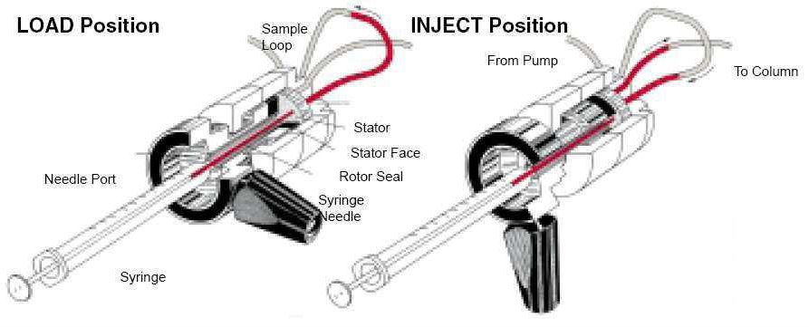
- Syringe injectors

Rheodyne injector

The heart of the system is the column. Many different reverse phase columns will provide excellent specificity for any particular separation. It is therefore best to routinely attempt separations with a standard C8 or C18 column (e.g. Zorbax RX C8) and determine if it provides good separation. Types of columns include:
Guard column: Protect the analytical column from impurities and foreign substances, no

separation will be occurred in guard column

Analytical column: Separation of compounds will take place in analytical column.

  - Length (5-15 cm) much shorter than GC column

  - Diameter (4 mm to 50mm)

  - Particle size (3- 10 mm)

Based up on the type of column material columns are classified into\

    - Normal phase columns

    - Reverse phase columns

    - Size exclusion columns

    - Ion exchange columns

    - Chiral columns

HPLC Detectors

The HPLC detector, located at the end of the column, must register the presence of various components of the sample, but must not detect the solvent. For that reason there is no universal detector that works for all separations. A common HPLC detector is a UV absorption detector, as most medium to large molecules absorb UV radiation. Detectors that measure fluorescence and refractive index are also used for special applications. A relatively new development is the combination of an HPLC separation with an NMR detector. This allows the pure components of the sample to be identified and quantified by nuclear magnetic resonance after having been separated by HPLC, in one integrated process.

List of most common HPLC detectors

- UV-Visible

- Refractive Index

- Fluorescence

- Conductivity (for ion chromatography)

- Photodiode array detector

- Amperometric detector

- Mass spectroscopy detectors

- NMR detectors RECORDERS&INTEGRATORS Recorders : Used to record the responses
Integrators: Used to data processing, record individual peaks with Rt, height, width of peaks, peak area, % of area

Typical HPLC chromatogram
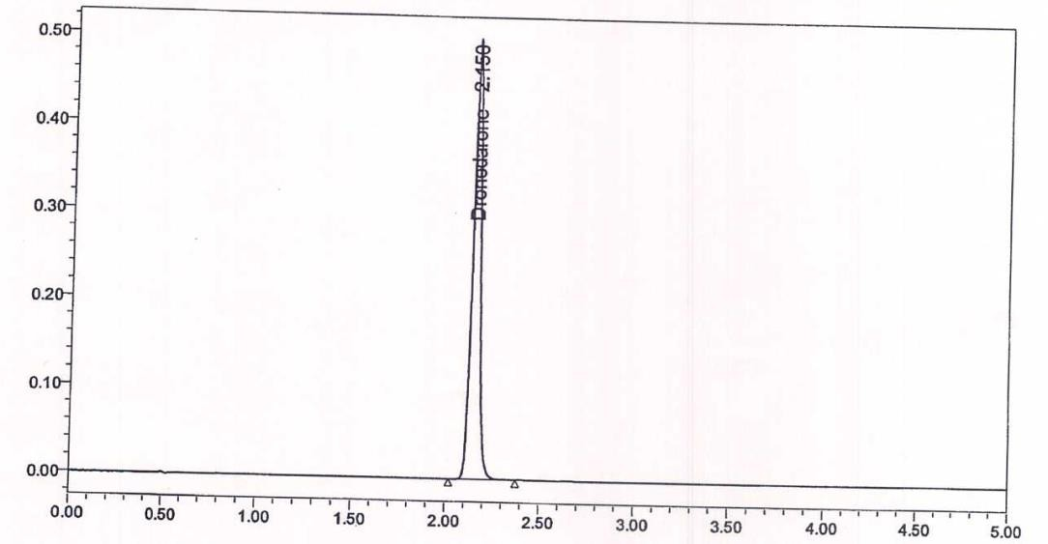
APPICATIONS OF HPLC

  - Pharmaceutical field

  - Chemical and Petrochemical industry

  - Forensic studies

  - Biochemical separations

  - Food analysis

  - Qualitative analysis : Checking the purity of a compound

  - Quantitative Analysis

- Direct Comparison method

- Calibration curve method

- Internal standard method

  - HPLC is used to analyze raw materials and finished products to assure that pre-established quality levels are being met.
  - Multi component analysis

  - Isolation and identification of drugs

  - Stability studie

5. DETERMINATION OF λ MAX OF KMNO4 BY COLORIMETRY Aim: To determine λ max of KMnO4 solution.
Instrument: colorimeter

Apparatus: 100ml volumetric flask, test tubes, beakers Chemicals: KMnO4 solution, distilled water Principle:
Spectroscopy is the tool for study of atomic and molecular structure. It deals with interaction of electronic radiation with matter involving the measurement and interpretation of the extension of absorption or emission of electromagnetic radiation by molecule.
λmax is defined as wavelength at which maximum absorption of radiation takes place. The extent to which a sample absorbs light depends strongly upon the wavelength of light and type chromophore present in the analyte. Chromophore is a functional group or a part of the molecule responsible for the absorption of electromagnetic radiation at a specific frequency. λmax is characteristic of a compound and provides information of the electronic transitions occurs in the analyte. In order to obtain the highest sensitivity and to minimize deviations from Beer's Law, analytical measurements are made using light with a wavelength of λmax.
NOTE: λmax is independent from the concentration of the analyte.

Procedure:
  - Prepare a solution of 100 µg/ml of KMnO4
  - Switch on the instrument and warm up for 15 minutes.
  - Using distilled water as blank adjust to 100% transmittance or zero absorbance.
  - Take the solution of KMnO4 in cuvette and measure the absorbance from 400-800 nm with interval of 40nm.
  - Plot the graph between wavelength vs absorbance and note the wavelength at which maximum absorbance is observed.

Observation:

S.No | Wavelength (nm) | Absorbance
1 | 400
2 | 440
3 | 480
4 | 520
5 | 560
6 | 600
7 | 640
8 | 680
9 | 720
10 | 760
11 | 800

Report:

The λ max of potassium permanganate (KMnO4) was found to be …… nm.

Reference:

A Practical Approach to Pharmaceutical Analysis, Nema et al, CBS Publications, P5-6.

Viva questions:

- Define λ max .
- What is mean by wave length and write the units.
- Write the wave length range of UV and Visible light.
- Define chromophore.
- Write the wavelength ranges in VIBGOYR

DETERMINATION OF λ MAX OF PARACETAMOL SOLUTION BY UV-VISIBLE SPECTROPHOTOMETER
Aim: To determine λ max of paracetamol solution Instrument: UV-Visible Spectrophotometer Apparatus: 100ml volumetric flask, test tubes, beakers Chemicals:, paracetamol, distilled water

Principle:

Spectroscopy is the tool for study of atomic and molecular structure. It deals with interaction of electronic radiation with matter involving the measurement and interpretation of the extension of absorption or emission of electromagnetic radiation by molecule.
λmax is defined as wavelength at which maximum absorption of radiation takes place. The extent to which a sample absorbs light depends strongly upon the wavelength of light and type chromophore present in the analyte. Chromophore is a functional group or a part of the molecule responsible for the absorption of electromagnetic radiation at a specific frequency. λmax is characteristic of a compound and provides information of the electronic transitions occurs in the analyte. In order to obtain the highest sensitivity and to minimize deviations from Beer's Law, analytical measurements are made using light with a wavelength of λmax.
NOTE: λmax is independent from the concentration of the analyte.\

Procedure:
  - Prepare a solution of 100 µg/ml of paracetamol.
  - Switch on the instrument and warm up for 15 minutes.
  - Using distilled water as blank adjust to 100% transmittance or zero absorbance.
  - Take the solution of paracetamol in cuvette and scan from 200-400 nm.
  - Repeat its for 3-6 times and consider the wavelength at which maximum absorption of radiation takes place. It is known as λmax.

Report:

The λ max of potassium paracetamol was found to be …… nm.

- EFFECT OF SOLVENTS ON ABSORPTION MAXIMA OF DELTIAZEM HCl Aim: To determine the effect of solvents on absorption maxima of deltiazem HCl Apparatus: Volumetric flask, pipette, beaker, glass rod
Chemicals: Deltiazem HCl, distilled water, methanol, NaoH

Principle:
λ max is a constant value in a particular solvent as the solvent system varies, the λ max also varies, The shift in absorption maxima depends on the polarity of solvent and the pH of the solvent.
Molecule which undergo π-π* transition, the π* state is more polar and stabilized more in polar solvent relative to nonpolar, thus in going from nonpolar to polar solvent there is a red shift or bathochromic shift (increase in λmax).
For n-π* transition, the n state is much more easily stabilized by polar solvent (H-bonds and association), so in going from nonpolar to polar solvent there is a blue shift or hypsochromic shift (decrease in λmax).

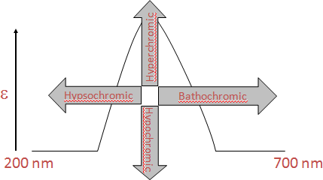

Procedure:

Weigh accurately 100mg of deltiazem HCl powder and add distilled water to make it 100ml in a volumetric flask, shake well and take 10 ml of above solution and dilute to 100ml with distilled water. Scan the above solution to get spectrum against the distilled water as blank. Similarly make the deltiazem HCl solution by using methanol and NaOH as solvents. Scan the above solution to get spectrum against the methanol and NaOH as blanks . Finally overlap all the spectras and observe the shift in λ max

Report:

The absorption maxima using water was found at nm The absorption maxima using methanol was found at nm The absorption maxima using NaOH was found at nm Questions:
- Discuss the effect of solvent on absorption maxima.

- Define Hypsochromic shift with examples.

- Define Bathochromic shift with examples. 4.Write the principle of Beer-Lamberts law.
- Explain about different types of electronic transitions involved in Absorption spectroscopy.

  - ESTIMATION OF SALICYLIC ACID BY COLORIMETRY AIM: To estimate the amount salicylic acid in given sample by colorimetric method.
CHEMICALS:Salicylic acid, Hydrochloric acid (1%v/v), Ferric chloride, Distilled water.

PRINCIPLE:

The increasing concentrations of salicylic acid is treated with 1% ferric chloride reagent (1g FeCl3 in 100 mL of 1% Hydrochloric acid). The free phenolic hydroxyl group present in salicylic acid reacts with the reagent and forms a violet colored complex i.e., ferric salicylate which is proportional to the concentration of salicylic acid.
PROCEDURE: Ferric chloride reagent is prepared by adding 1 gm of FeCl3 to 100 ml of 1% HCl (1mL concentrated hydrochloric acid added to 100mL of distilled water). Stock solution of salicylic acid (1mg/ml) is prepared by dissolving 100 mg of salicylic acid in few ml of methanol and made up to 100 ml with distilled water in a volumetric flask. 10 ml of this stock solution is diluted with 100 ml distilled water to get 100 μg/ml salicylic acid solution. Take the respective samples in each test tube, add the reagent and distilled water to make total volume of 10 ml (as per mentioned in table) and measure the absorbance of the violet colored complex usingUV-Visible spectrophotometer or colorimetry at wavelength of 525 nm against blank sample (without salicylic acid).

Volume of stock solution (mL) | Volume of reagent (mL) | Distilled water to make 10 mL | Concentration of Salicylic acid (μg/mL) | Absorbance
0 | 1 | 9 | 0 | 0
1 | 1 | 8 | 10
2 | 1 | 7 | 20
3 | 1 | 6 | 30
4 | 1 | 5 | 40

5 | 1 | 4 | 50
6 | 1 | 3 | 60

Plot a graph taking concentration on X-axis and observed absorbance values on Y-axis, draw a best fit line and record r2 value (regression coefficient) and equation of straight line.

REPORT:

  - ESTIMATION OF PARACETAMOL IN TABLETS BY USING STANDRAD ABSORPTIVITY VALUE
Aim: To estimate the percentage purity of Paracetemol percent in the given sample

Apparatus: Mortar and pestle, beaker, standard flasks, funnel

Chemicals: Paracetemol tablets, water, NaOH

Principle:

Estimation of paracetamol by UV- Visible spectrophotometer depends on the Beer’s -Lambert’s law

Beer’s law :States that “the intensity of a beam of monochromatic light decreases exponentially with increase in the concentration of absorbing species arithmetically”
- dI / dc α I

Lambert’s law : states that the rate of decrease of intensity (monochromatic light) with the thickness of the medium is directly proportional to the intensity of incident light
–dI / dt α I
Beer – lamberts law
I = Io e– kct
I = Io 10– kct (converting natural algorithm to base 10) I / Io = 10–kct (rearranging terms)
Io / I = 10kct (inverse on both side)
Log Io / I = kct (taking log on both sides) --- Equation 4
It can be learnt that transmittance (T) = I / Io and Absorbance (A) = log 1 / T Hence A = log 1 / I/ Io
A = log Io /I --- Equation 5, by Using Equation 4 & 5 , Since A= log Io /I and log Io /I = Kct we can infer that A= Kct (instead of K, we can use ε)
A= εct or A= act or A= A ^{1%} ct
1cm
Where:
A = Absorbance or optical density ε = Molecular extinction coefficient
c = Concentration of the drug (mol/lit)
t = Path length (normally 10mm or 1cm)
Paracetemol is chemically known as Para-acetyl-aminophenol. Estimation of Paracetemol concentration in tablets can be alone done by U.V. spectrophotometry by using standard Absorptivity value (A 1%1cm). In this the absorbance of the diluted sample solution is observed at

257nm. From this calculate the concentration of Paracetemol taking 715 on A ^{1%} value at maximum of about 257nm
1cm

Procedure:
- Weigh and powder 20 tablets
- Take the powder equivalent to 0.15gm
- Add 50ml of 0.1 M NaOH and dilute to 100ml with water
- Shake the mixture for 15 minutes and add sufficient water to produce 200ml
- The resulting solution is mixed and filtered
- Take 10ml of above solution and dilute to 100ml with water
- To 10ml of resulting solution add 10ml of 0.1 N NaOH
- Make up the volume to 100ml with water and mix it
- Measure the absorbance of resulting solution at 257nm by using 715 as A 1%1cm value

Report:
The purity of Paracetemol in the given sample of tablet powder was found to be

Questions:

- Write the principle for standard absorptivity value of Paracetamol in tablets.
- Write the absorptivity value of Paracetamol
- Write the λ max of Paracetamol
- Write the dilution factor in the above given procedure.
- Explain application of spectrophotometery.

ESTIMATION OF PARACETAMOL BY USING CALIBRATION CURVE METHOD

AIM: To estimate the percentage purity of Paracetamol present in the given sample APPRATUS: Beaker, glass rod, volumetric flask, measuring cylinder, pipette CHEMICALS: Paracetamol powder, Paracetamol tablets, NaOH, water PRINCIPLE:
The assay of light absorbing substance may be quickly carried out by using Beer – Lamberts Law.
Beer’s law :States that “the intensity of a beam of monochromatic light decreases exponentially with increase in the concentration of absorbing species arithmetically”
- dI / dc α I

Lambert’s law : states that the rate of decrease of intensity (monochromatic light) with the thickness of the medium is directly proportional to the intensity of incident light
–dI / dt α I
Beer – lamberts law
I = Io e– kct
I = Io 10– kct (converting natural algorithm to base 10) I / Io = 10–kct (rearranging terms)
Io / I = 10kct (inverse on both side)
Log Io / I = kct (taking log on both sides) --- Equation 4
It can be learnt that transmittance (T) = I / Io and Absorbance (A) = log 1 / T Hence A = log 1 / I/ Io
A = log Io /I --- Equation 5, by Using Equation 4 & 5 , Since A= log Io /I and log Io /I = Kct we can infer that A= Kct (instead of K, we can use ε)
A= εct or A= act or A= A ^{1%} ct
1cm
Where:
A = Absorbance or optical density ε = Molecular extinction coefficient
c = Concentration of the drug (mol/lit)
t = Path length (normally 10mm or 1cm)

Paracetamol is chemically known as N-(4-hydroxyphenyl)acetamide. Estimation of paracetamol concentration in tablet can be done by UV- spectrophotometry using calibration curve method. In

this the absorbance of the diluted sample solution is observed at 257nm. From this concentration is calculated.
CALIBRATION CURVE: It is a standard graph or linear plot of serial standard dilutions.Graph plotted between concentration(x-axis) Vs response(Y-axis). The curve should be passed through the origin and r² value should be greater than 0.99 and less than 1.

PROCEDURE:
Preparation of stock solution: 100mg of paracetamol powder is dissolved in 100ml of 0.1N NaOH (1mg/ml)
Working standard: From the stock solution, 10 ml is taken and diluted to 100 ml with 0.1N NaOH (100µg/ml)

Dilutions of Linearity Range: From the working standard 1ml,2ml.3ml, 4ml,5ml is taken into individual volumetric flasks (10ml) and make up the volume by usimg 0.1N NaOH to get the concentrations about 10,20.30,40,50 µg/ml respectively.

Estimation of amount of Pracetamol in tablets:

- Weigh and powder 20 tablets
- Take the powder equivalent to 0.15gm
- Add 50ml of 0.1 M NaOH and dilute to 100ml with water
- Shake the mixture for 15 minutes and add sufficient water to produce 200ml
- The resulting solution is mixed and filtered
- Take 10ml of above solution and dilute to 100ml with water
- To 10ml of resulting solution add 10ml of 0.1 N NaOH
- Make up the volume to 100ml with water and mix it
- Measure the absorbance of resulting solution at 257nm

REPORT:

The purity of Paracetemol in the given sample of tablet powder was found to be

QUESTIONS:

    - Write the chemical name of Paracetamol
    - Calculate the dilution factor of given Paracetamol sample
    - What is mean by r² value and what is the limit for r²
    - Write the relationship between absorbance and transmittance

11. ASSAY OF CHLORAMPHENICOL CAPSULES BY USING UV-VISIBLE SPECTROPHOTOMETRIC METHOD
Aim: To estimate the percentage purity of chloramphenicol percent in the given capsules

Appratus: Mortar and pestle, beaker, standard flasks, funnel

Chemicals: Chloramphenicol capsules, water

Principle:

The assay of an absorbing substance may be quickly carried out by using Beer – Lamberts Law. I = Io e– kct
A= ε ct

Where: A = Absorbance or optical density. ε = Molecular extinction coefficient ,c = Concentration of the drug (mol/lit) ,t = Path length (normally 10mm or 1cm)
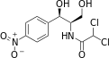

Chloramphenicol is chemically known as 2,2-dichloro-N-[(1R,2R)-1,3-dihydroxy-1-(4- nitrophenyl)propan-2-yl]acetamide. Estimation of chloramphenicol concentration in capsule can be alone done by U.V. spectrophotometry by using standard Absorptivity value (A 1%1cm). In this the absorbance of the diluted sample solution is observed at 278nm. From this calculate the concentration of chloramphenicol by taking 298 as A 1%1cm value.

Procedure:

- Weigh 20 capsules and mix the contents.
- Take the powder equivalent to 0.200gm of chloramphenicol
- Add 500ml of distilled water, warm gently to get a clear solution and dilute to 1000ml with distilled water
- Take 10ml of above solution and dilute to 100ml with distilled water
- To 10ml of resulting solution add 10ml of 0.1 N NaOH
- Measure the absorbance of resulting solution at 278 nm by using 298 as A 1%1cm value

Report:

The purity of chloramphenicol in the given sample was found to be

Questions:

- Write the limitations of Beer – Lambert’s law.
- Write the uses of chloramphenicol.
- What is mean by A 1%1cm value.
- Define chromophore and find out the chromophore and auxochrome present in chloramphenicol .
- Explain application of spectrophotometery.

  - EFFECT OF PH ON ABSORPTION MAXIMA OF PARACETAMOL AIM: To determine the effect of PH on λ max of paracetamol
APPRATUS: Volumetric flask, pipette, glass rod, beaker

CHEMICALS: Buffer – 4, 7, 9 capsules, Paracetamol, distilled water

PRINCIPLE:

High pH solutions absorb at higher wavelengths. Whereas low pH solutions absorb at lower wavelengths.
C6H5OH C6H5O- + H+
In the given equation when the equilibrium of the reaction lies to the right, then the wavelength of the absorbance would decrease, because the concentration of H⁺ has increased (ie lower pH). The increased H⁺ concentration stabilize the ground state as opposed to the excited electronic state leads to decrease in wavelength (hypsochromic (blue) shift), which in turn is an increase in energy. In other words, more energy is required for an electronic excitiation to occur (stabilised ground state by the H⁺).

PROCEDURE:

- Weigh accurately 100mg of Paracetamol powder and add it to P^{H}-4 buffer in 100ml volumetric flask
- Shake well and mask it as solution A
- Similarly add 100mg of Paracetamol powder to P^{H} – 9 and P^{H} -7 buffer in 100ml volumetric flask
- Shake well and mark it as solution B and C respectively
- Prepare blank solutions of P^{H} 4, 7, 9
- Solution A is taken and spectrum is plotted by U.V. Visible spectrophotometer and λ max is obtained against the blank P^{H} – 4
- Similarly plot for the solution B and C against P^{H} – 9 and P^{H} -7 as blank
- Overlap spectra and observe the shift in λ max and report it

REPORT:

In neutral PH – λ max – ….. nm In acidic PH – λ max – ….. nm In alkaline PH – λ max – …. nm

  - EFFECT OF SOLVENT ON ABSORPTION MAXIMA OF PARACETEMOL AIM: To determine the effect of solvent on absorption maxima
APPRATUS: Volumetric flask, pipette, beaker, glass rod CHEMICALS: Paracetemol, distilled water, methanol PRINCIPLE:
λ max is a constant value in a particular solvent as the solvent system varies, the λ max also varies,The shift in absorption band depends on the polarity of solvent and the solute. For π -> π* transition, the π* state is more polar and stabilized more in polar solvent relative to nonpolar, thus in going from nonpolar to polar solvent there is a red shift or bathochromic shift (increase in λmax). For n -
> π* transition, the n state is much more easily stabilized by polar solvent (H-bonds and association), so in going from nonpolar to polar solvent there is a blue shift or hypsochromic shift (decrease in λmax).

PROCEDURE:

Weigh accurately 100mg of Paracetemol powder and add distilled water to make it 100ml in a volumetric flask, shake well and scan the above solution to get spectrum against the distilled water as blank. Similarly make the paracetamol solution by using methanol as solvent. Scan the above solution to get spectrum against the distilled methanol as blank. Finally overlap both the spectra and observe the shift in λ max

REPORT:

The absorption maxima using methanol was found at higher wavelength.

Questions:

1.Discuss the effect of solvent on absorption maxima. 2.Explain about Hypsochromic shift and Bathochromic shift.
3.Write the chemicals required for effect of solvent on Absorption maxima. 4.Write the principle for Beer-Lamberts law.
- Explain about different electronic transitions involved in Absorption spectroscopy.

14. IR INTERPRETATION

Infrared spectroscopy (IR) measures the bond vibration frequencies in a molecule and is used to determine the functional groups and bonds present in chemical substance. The infrared region of the spectrum encompasses radiation with wave numbers ranging from about 12,500 to 50cm⁻¹ (or) wave lengths from 0.8 to 200µ.
The infrared region constitutes 3 parts

  - The near IR (0.8 -2.5 µm) (12,500-4000 cm⁻¹)
  - The middle IR (2.5 -15 µm) (4000-667 cm-¹)
  - The far IR (15-200 µm) (667-50 cm-¹)

PRINCIPLE

The absorption of infra red radiation leads to excitation of molecule and change in shape of the molecule because of stretching of bonds, bending of bonds, or internal rotation around single bonds. Vibrational transitions which are accompanied by a change in dipole moment of the molecule are called infrared active transitions and one which are not accompanied by change in dipole moment are not IR active transitions.
Another regions in infrared spectrum are

Group frequency region (2.5 – 8.0 µm) (4000 - 1300 cm-¹)
Finger print region (8.0 - 25 µm) (1300 – 400 cm-¹)
- 4000 − 2500 cm⁻¹: Absorbance of single bonds formed by hydrogen and other elements
e.g. O−H, N−H,C−H
- 2500 − 2000 cm⁻¹: Absorbance of triple bonds e.g. C≡C, C≡N
- 2000 − 1500 cm⁻¹: Absorbance of double bonds e.g. C=C, C=O
- 1500 − 400 cm⁻¹: This region often consists of many different, complicated bands. This part of the spectrum is unique to each compound and is often called the fingerprint region. It is rarely used for identification of particular functional groups

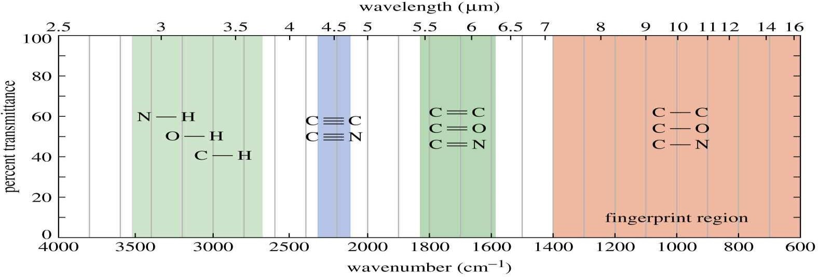
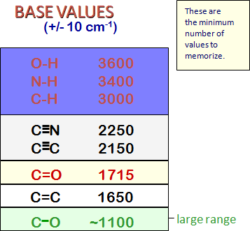
C=O IS SENSITIVE TO ITS ENVIRONMENT
EACH DIFFERENT KIND OF C=O COMES AT A DIFFERENT FREQUENCY
acid
chloride
ester
carboxylic
aldehydeketoneacidamide
O
RC
O
O
Cl
RC
OR'
RC
H
O
RC
O
RC
R
OH
O
RC
NH2
1800
1735
1725
1715
1710
1690

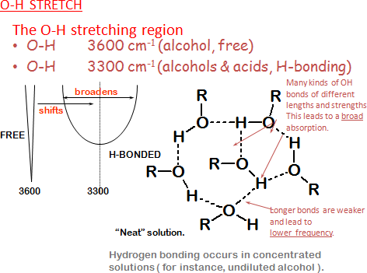

anhydride
O
RC
O
O
CR
1810 and 1760
( two peaks )
THESE VALUES ARE WORTH LEARNING
all are +/- 10 cm-1
BASE VALUE

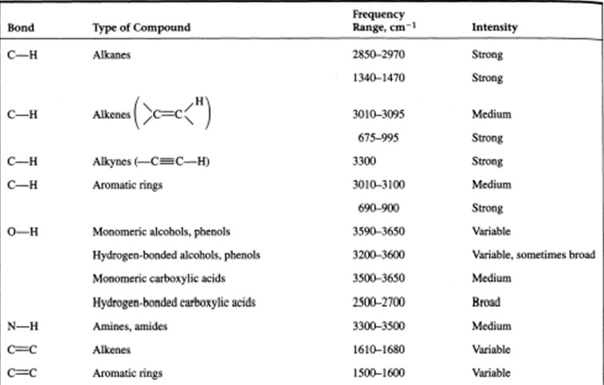

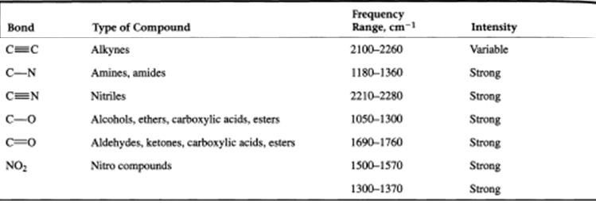

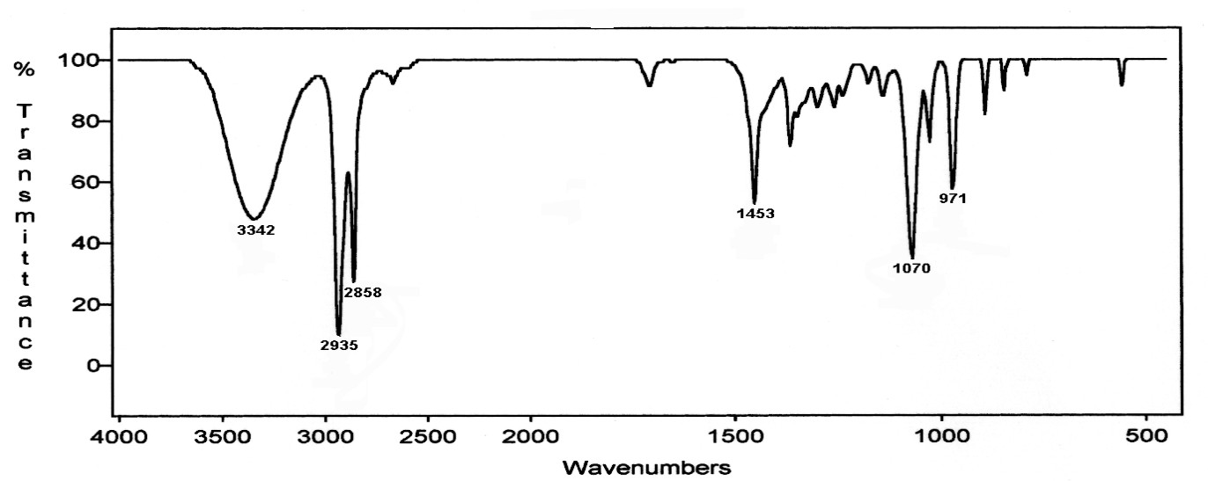
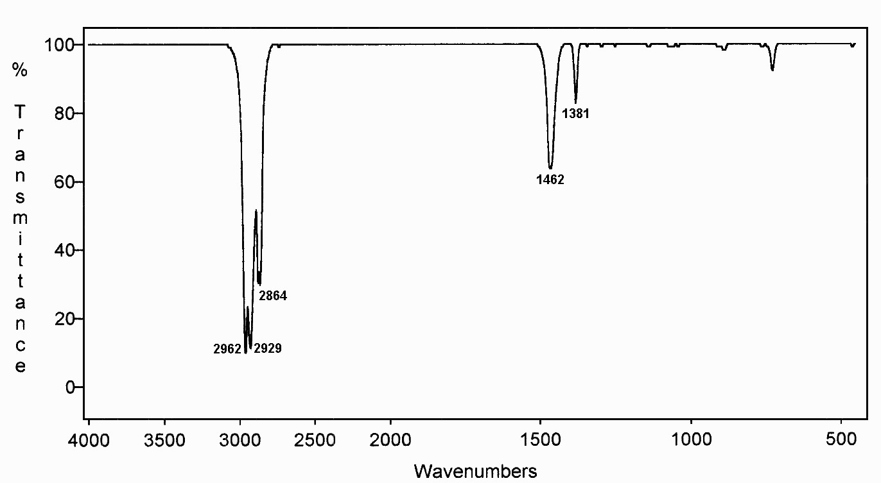

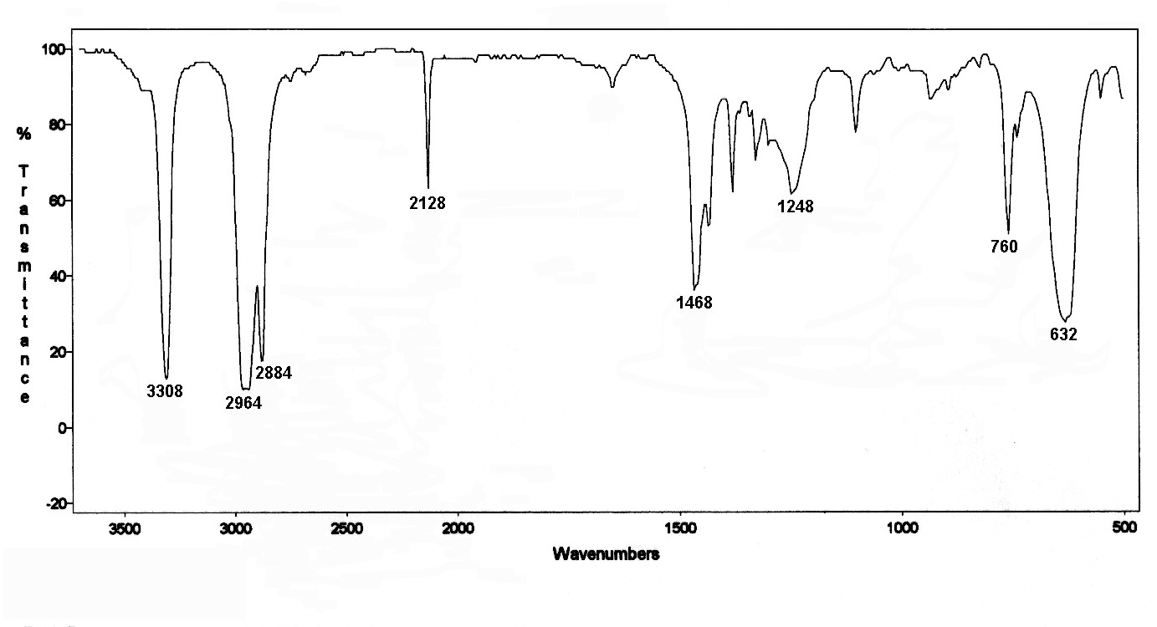

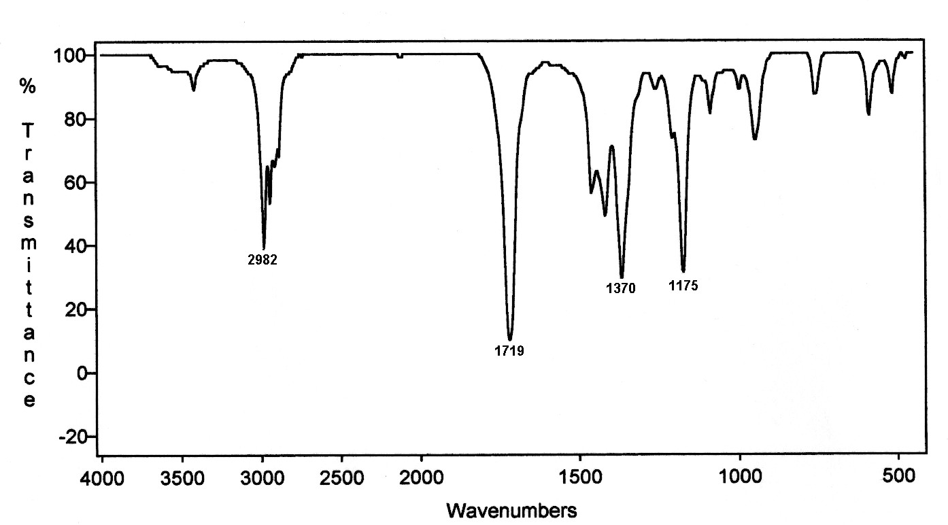

15.Estimation of Quinine sulphate by Fluorimetry
Aim : To estimate the amount of Quinine sulphate present in given sample by fluorimetry.

Requirements : Quinine sulphate , Fluorimeter, Sulphuric acid.

Apparatus: Pipette, volumetric flask, measuring cylinder.

Principle :

Fluorescence is the emission of visible light by a substance that has absorbed light of a different wavelength. The emitted photon has a longer wavelength and lower energy. As the excitation of the molecule is due to the absorption of a photon (light), these types of luminescence are called photoluminescence. Fluorescence is also defined as the radiation emitted in the transition of a molecule from a singlet excited state to a singlet ground state.
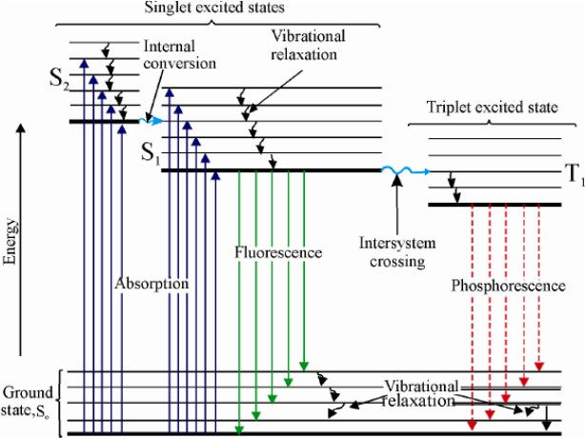
Fluorescence is also defined as the radiation emitted in the transition of a molecule from a singlet excited state to a singlet ground state. The intensity of the emitted radiation proportional to concentration of sample. such measurement form the basis of a sensitive method of analysis called the fluorometry. Fluorometric methods of analysis have found application in many situations of pharmaceutical interest such as in analysis of riboflavin, thiamine,reserpine, quinine sulphate in drug dosage forms.

Procedure;

Preparation of 0.1 N H2SO4:-
Pipette out 2.7 ml of conc H2SO4 to 100 ml of water and then make it up to 1000 ml with water.

Preparation of standard Quinine sulphate solution

- Weigh accurately 100mg of Quinine sulphate powdered drug
- Dissolve in 100 ml of 0.1 N conc H2SO4 to get 1mg/ml
- Take 10 ml of above solution and dilute to100 ml with 0.1N H2SO4(100µg/ml)
- Again 10ml of above solution dilute to 100ml with 0.1N H2SO4(10µg/ml)
- Pipette out 0.5,1, 1.5, 2,2.5,3 ml of above diluted standard quinine sulphate solution in to a set of 10 ml volumetric flask and make up to 10 ml with 0.1N H2SO4 to get concentration of 0.5,1,1.5,2,2.5,3 µg/ml respectively.
- Switch on the instrument and stabilize for 10-15min.
- Set excitation and emissiom filters at the wavelengths 365 and 459nm respectively.
- Set the fluorescence intensity to 0% by using 0.1N H2SO4 as blank and 100% by using highest concentration of the standard solution.Measure the fluorescence of serial dilutions and and plot the calibration curve ( fluorescence intensity Vs concentration).

Observation:

S.No | Concentration (µg/ml) | % Fluoroscence intensity
1 | 0.5
2 | 1
3 | 1.5
4 | 2
5 | 2.5
6 | 3
7 | Unknown

Report : The amount of Quinine sulphate present in the given sample was found to be ……..

QUESTIONS

- Write the principle of Fluorimetry.
- What is Fluorescence.Write the examples a for Fluoresent substance. 3.Write difference between UV-Visible spectroscopy and Fluorimetry.

- What is the difference between Fluorescence and Phosphorescence.

- Write the applications of Fluorimeter.

- EFFECT OF QUENCHING ON THE FLUORESCENCE OF QUININE SULPHATE Aim: To estimate the effect quenchingon the fluorescence of Quinine sulphate by Fluorimetry. Requirements: Quinine sulphate , Fluorimeter, Sulphuric acid, KI.
Apparatus: Pipette, volumetric flask, measuring cylinder.

Principle: The reduction in fluorescence intensity due to certain ions is known as quenching. These processes can occur during the excited state or they may occur due to formation of complexes in the ground state. Quenching is due to various factors like pH, concentration, temperature, viscosity, and presence of certain ions like halides.
Quenching mainly is of four types:
  - Self quenching
  - Chemical quenching
  - Collisional quenching
  - Static quenching
Presence of halides leads to quenching due to Collision.

Procedure;

Preparation of 0.1 N H2SO4:-
Pipette out 2.7 ml of conc H2SO4 to 100 ml of water and then make it up to 1000 ml with water.

Preparation of standard Quinine sulphate solution

- Weigh accurately 100mg of Quinine sulphate powdered drug
- Dissolve in 100 ml of 0.1 N H2SO4 to get 1mg/ml
- Take 10 ml of above solution and dilute to100 ml with 0.1N H2SO4(100µg/ml)
- Again 10ml of above solution dilute to 100ml with 0.1N H2SO4(10µg/ml) from this finally prepare 1µg/ml solution.

Preparation of KI solution

- Weigh accurately 100mg of KI, dissolve in 100 ml of 0.1 N conc H2SO4 to get 1mg/ml
- Take 10 ml of above solution and dilute to100 ml with 0.1N H2SO4(100µg/ml)
- In six 10 ml volumetric flasks, take 1ml of 1µg/ml solution in each.
- Add 1,2,3,4 and 5ml of KI solution in each flask. Make up the volume with 0.1N H2SO4
- Switch on the instrument and stabilize for 10-15min.

- Set excitation and emissiom filters at the wavelengths about 365 and 459nm respectively.
- Set the fluorescence intensity to 0% by using 0.1N H2SO4 as blank and 100% by using highest concentration of the standard solution (not containing KI). Measure the fluorescence of serial dilutions and plot a graph between (volume of KI Vs fluorescence intensity ).

Observation:

S.No | Vol. of KI added | % Fluoroscence intensity
1 | 0
2 | 1
3 | 2
4 | 3
5 | 4
6 | 5

Report :

Questions

- Define quenching.
- How temperature and viscosity effect the quenching.

- Write difference between self quenching and chemical quenching. 4.What is the difference between Fluorescence and Phosphorescence. 5.Write the factors influence the fluorescence.

17. Estimation Of Sodium Concentration By Flame Photometry

Aim : To estimate the concentration of sodium present in given sample by flame photometry.

Requirements : Sodium chloride, Distlled water, Flame Photometer.

Apparatus: Pipette, volumetric flask, measuring cylinder.

Principle : Flame photometry is also known as atomic emission spectrometry. It works on the basis of heating the metal, in this case sodium, such that the atoms of the metal travel from ground state to their excited state. The atoms then return to their ground state and release their energy as photons of ultraviolet radiation. The wavelength of the UV radiation is then measured. When a liquid sample consisting a metallic salt solution is introduced into a flame, the following steps takes place
  - The solvent gets evaporated
  - The solid salt gets converted to its gaseous state
  - The dissociation of either portion or total gaseous molecules give rise to neutral atoms (or) free radicals
  - The neutral atoms are excited by the thermal energy of the flame which are unstable
  - They instantly emit photons and return to it’s ground state
The measurement of photons (emitted radiations forms the fundamental basis of flame photometry

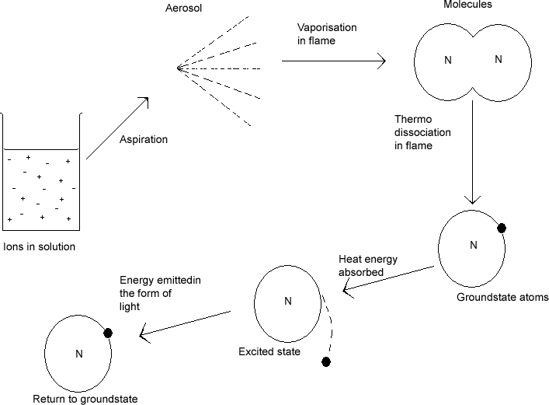

The intensity of radiation emitted by depends upon proportion of thermally exited atoms

Procedure;

    - Weigh accurately 100mg of sodium chloride powdered drug
    - Dissolve in 100 ml of distilled water to get 1mg/ml
    - Take 10 ml of above solution and dilute to100 ml with distilled water (100µg/ml)
    - Pipette out 5,10, 20,30,40,50 ml of above diluted standard solution in to a set of 100 ml volumetric flask and make up to 100 ml with to get concentration of 5,10, 20, 30,40, 50 µg/ml respectively.
    - Switch on the instrument, select sodium filter and stabilize for 10-15min.
    - Set the gas in flame in order to get the non-luminous flame and air pressure at 0.4 to 0.5Kg/cm²
    - Set the flame intensity to 0% by using distilled water as blank and 100% by using highest concentration of the standard solution. Measure the % flame intesity of serial dilutions and plot the calibration curve (% intensity Vs concentration).
    - Find out the concentration of unknown sample from calibration curve.

Observation:

S.No | Concentration (µg/ml) | % Flame intensity
1 | 5
2 | 10
3 | 20
4 | 30
5 | 40
6 | 50
7 | Unknown

Report : The concentration of sodium present in the given sample was found to be ……..

QUESTIONS

- Write the principle of flame photometry.
- Write the examples for atomic emission spectrometry.

- Write difference between UV-Visible spectroscopy and Flame photometry..

- Write the applications of Flame photometry .

18. Estimation Of Potassium Concentration By Flame Photometry

Aim : To estimate the concentration of potassium present in given sample by flame photometry.

Requirements : Potassium chloride, Distlled water, Flame Photometer.

Apparatus: Pipette, volumetric flask, measuring cylinder.

Principle : Flame photometry is also known as atomic emission spectrometry. It works on the basis of heating the metal, in this case sodium, such that the atoms of the metal travel from ground state to their excited state. The atoms then return to their ground state and release their energy as photons of ultraviolet radiation. The wavelength of the UV radiation is then measured. When a liquid sample consisting a metallic salt solution is introduced into a flame, the following steps takes place
  - The solvent gets evaporated
  - The solid salt gets converted to its gaseous state
  - The dissociation of either portion or total gaseous molecules give rise to neutral atoms (or) free radicals
  - The neutral atoms are excited by the thermal energy of the flame which are unstable
  - They instantly emit photons and return to it’s ground state
The measurement of photons (emitted radiations forms the fundamental basis of flame photometry

The intensity of radiation emitted by depends upon proportion of thermally exited atoms

Procedure;

    - Weigh accurately 100mg of potassium chloride powdered drug
    - Dissolve in 100 ml of distilled water to get 1mg/ml
    - Take 10 ml of above solution and dilute to100 ml with distilled water (100µg/ml)
    - Pipette out 5,10, 20,30,40,50 ml of above diluted standard solution in to a set of 100 ml volumetric flask and make up to 100 ml with to get concentration of 5,10, 20, 30,40, 50 µg/ml respectively.
    - Switch on the instrument, select sodium filter and stabilize for 10-15min.
    - Set the gas in flame in order to get the non-luminous flame and air pressure at 0.4 to 0.5Kg/cm²
    - Set the flame intensity to 0% by using distilled water as blank and 100% by using highest concentration of the standard solution. Measure the % flame intesity of serial dilutions and plot the calibration curve (% intensity Vs concentration).
    - Find out the concentration of unknown sample from calibration curve.

Observation:

S.No | Concentration (µg/ml) | % Flame intensity
1 | 5
2 | 10
3 | 20
4 | 30
5 | 40
6 | 50
7 | Unknown

Report : The concentration of sodium present in the given sample was found to be ……..

QUESTIONS

- Write the principle of flame photometry.
- Write the examples for atomic emission spectrometry.

- Write difference between UV-Visible spectroscopy and Flame photometry..

- Write the applications of Flame photometry .

19. POTENTIOMETRIC TITRATION OF STRONG ACID Vs STRONG BASE

AIM: To determine the exact equivalent point and normality of 0.1 N HCl by titrating it with 0.1N NaOH solution potentiometrically.
CHEMICALS: NaOH, distilled water, HCl.

APPARATUS: pH meter, potentiometer, Burette, Beaker, Electrodes, Measuring cylinder.

PRINCIPLE: Potentiometric determination of end point depends upon the potential across to suitable reference and indicator electrodes immersed in solution changes sharply at the end point. This change is similar to colour change by ion by ion indicator by visual method. Potentiometric endpoint determination is more accurate and this titrations are useful when there is no suitable indictor available. End point will be accurately noted after plotting a graph between volume of titrant vs potential developed.

PROCEDURE:

Preparation of 0.1 N NaOH: 0.4 g of NaOH dissolved in 100 ml of H2O.

Preparation of 0.1 N Oxalic acid: 0.63 g of oxalic acid dissolved in 100 ml of water.

Preparation of 0.1 N HCl: 0.84 ml of conc. HCl is dissolved in 100 ml water.

Standardization of 0.1 N NaOH:

- Pipette out 20 ml of 0.1 N oxalic acid solution into beaker
- Dip the electrodes (saturated calomel electrode as reference electrode and glass electrode as indicator electrode) into the solution which is connected to a potentiometer.
- Take the prepared 0.1 N NaOH solution into a burette and add 0.5 ml of this to the beaker until the equivalent point of the titration is obtained.

- Pipette out 20 ml of standardised NaOH solution into a beaker and take the prepared HCl solution into a burette.
- Proceed the titration in the same way like oxalic acid.
- A graph is plotted between the volume of titrant add on X-axis and the potential difference on Y-axis in mV.

S.No. | Vol of titrant | pHof solution | e.m.f
1 | 0 ml
2 | 1 ml
3 | 2 ml
4 | 3 ml
5 | 4 ml
6 | 5 ml
7 | 6 ml
8 | 7 ml
9 | 8 ml
10 | 9 ml
11 | 10ml

REPORT: The endpoint in potentiometric titration of strong acid vs strong base was found to be

With pH---- and e.m.f was found to be-------

VIVA QUESTIONS

  - What is a potentiometric titration?
  - What are the electrodes used in the experiment?
  - What is the indicator electrode?
  - What is the Reference electrode?

  - What is neutralization point?
  - How can you determine the strength of acid from neutralization point?
  - What is the principle involved in potentiometric titration.
  - What is the single electrode potential?
  - What is meant by e.m.f?
  - What are the electrodes used in potentiometric titration
  - How do you confirm the end point in the potentiometric titration?
  - What are the advantages of potentiometric titrations?

20. CONDUCTOMETRIC DETERMINATION EQUIVALENCE POINT OF TITRATION OF A SOLUTION OF HYDROCHLORIC ACID BY A STANDARD
SOLUTION OF SODIUM HYDROXIDE.

AIM: To determination equivalence point of titration of a solution of hydrochloric acid by a standard solution of sodium hydroxide by Conductometry.
CHEMICALS: NaOH, oxalic acid, distilled water, HCl.

APPRATUS: Conductometer, Burette, Beaker, Electrodes, Measuring cylinder.

PRINCIPLE: Conductometric titrations works on the principle of Ohm's law. As current (i) is inversely proportional to Resistance (R) and the reciprocal of resistance is termed as Conductance, and its unit is Siemen (mho) cm ⁻¹. The conductivity of a solution depends on the number of ions and their mobility towards their respective electrodes.

R

V= Potential difference R=Resistance
I= Current flow
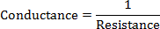
The main principle involved in this experiment is when HCl is taken in beaker, initially the conductivity is high because of the complete dissociate of HCl in to H⁺ and Cl⁻ and as NaOH is added, the OH⁻ of NaOH reacts with H⁺ to produce water. As a result conductivity of solution is gradually decreases after every addition of NaOH, until all H⁺ ions are reacted with OH⁻ to produce water. At the end point there is on H⁺ ion to react OH⁻ , now further addition of NaOH increases the conductance of solution due increasing no. of OH⁻ ions and a V shaped graph is obtained.

PROCEDURE:

Conductometric Titration:

- Switch on the coductometer and allow to stabilize for 30 min.
- Rinse the conductivity cell a number of times with double distilled water.
- Take 20 mL of 0.1 N HCl in a beaker and dip the conductivity cell in it, so that the cell should dip completely in solution.
- Note the temperature of the sample solution and accordingly set the temperature control or keep the cell in a thermostat at room temperature.
- Determine the initial conductance of acid.
- Add small amount of 0.1N NaOH solution (few drops) from burette, stir it and measure the conductance after each addition.
- Several readings has to note before and after the approximate end point
- Plot a graph between conductance and volume of titrant (NaOH solution) and determine the end point
- Calculate the normality of acid

Observation Table

S.NO | Vol. of NaOH Added in ml | Conductivity (mho)
1 | 0
2 | 1
3 | 2
4 | 3
5 | 4
6 | 5
7 | 6
8 | 7
9 | 8

10 | 9
11 | 10
12 | 11
13 | 12
14 | 13

REPORT: The end point of conductometric titration of strong acid Vs strong base was found to be

at ------- conductance and normality of acid was found to be----------

